28th January 2019

Dear Parent/Carer

SENIOR PHASE PARENTS’/CARERS’ MEETING ONLINE BOOKING SYSTEM

You are invited to make online appointments for the school’s next Parents’ Meetings. Our next two events are on:

- Tuesday 19th February 2019 for all S4 to S6 pupils in Mull and Skye House
- Tuesday 26th February 2019 for all S4 to S6 pupils in Arran and Lewis House

To make your appointments please go to: www.parents-booking.co.uk/kingspark . Please note: You need to type this address into your website browser’s ‘web address bar’. Try not to ‘Google’ search the website address, it will not be searchable that way.

Login by entering the required information in the fields pictured below:

- Your title and surname
- Your child’s first name, surname and date of birth
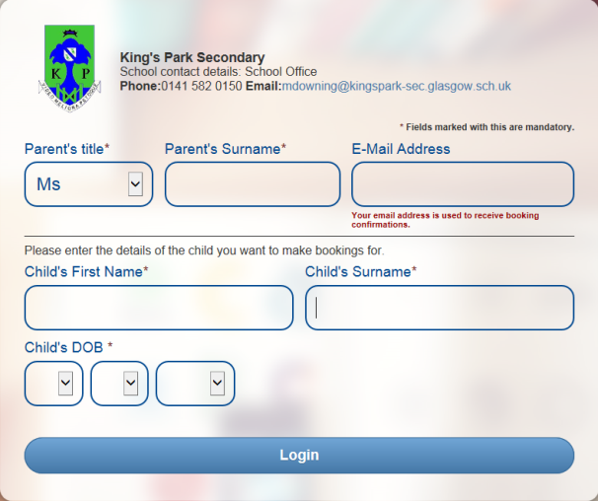

Please note: The login details you enter must match those we have on record for you. If you have not alerted the school to any relevant name changes, we will be expecting you to login with the details you gave us originally.

The booking system will allow you to make bookings from Tuesday 29th January and will close for bookings on the day before each event at 12.00 noon.

Once you have logged in, we suggest you use the ‘Booking Wizard’ to make your appointments, although a manual booking option (one booking at a time, one child at a time) also exists. In the Booking Wizard you will be shown your child and all of their teachers. Tick the teacher(s) you wish to book (there’s a ‘Select All’ link) and enter your availability at the bottom of the page. The wizard will use this information to calculate the best order for your appointments, to help you visit teachers in the most appropriate manner.

Troubleshooting Tips

- If you cannot login and have tried all the combinations you think we have on file, please contact the school office email: mdowning@kingspark-sec.glasgow.sch.uk
- The email address you can enter is only used to receive a confirmation of your appointment. It will not be used as a login ‘check’.

Please do not hesitate to contact myself or the school office if you require further information.

Yours sincerely

Kevin Kelly
Depute Head Teacher

