King’s Park Secondary School
Equality Policy

Rationale
Glasgow City Council Education Services is committed to equality and fairness, and our legal duties, obligations and associated responsibilities within the Equality Act 2010 across all our schools and early years establishments. We want to ensure that equality is embedded in all our establishments and that our values and cultures promote equalities. We want all our children and young people, staff, families and partners to feel highly valued and be treated fairly. We strive towards creating learning environments that reflect the diversity of the school community, both within the curriculum and in our workforce. We want everyone to have positive experiences and opportunities and recognise their contribution as global citizens to a world free from discrimination and one that promotes justice for all.

Our Equality policy seeks to ensure that everyone regularly thinks about how they are taking forward equality in their roles and settings as a catalyst for positive change, equality and fairness. It will encourage all to reflect on their commitment, activities and culture and how to adapt to a continually changing and rapidly evolving society.

In taking forward our Equality policy we are continuing to support the aim of creating a nurturing school within a nurturing city where children and young people feel respected and included.

We want schools to continue to celebrate the diversity of communities across our city, to challenge ourselves and each other, and consider our actions and impact across all the protected characteristics. Fundamentally, we support Glasgow’s vision of a world class city with a thriving and inclusive economy where everyone can flourish.

Introduction
This policy sets out King’s Park Secondary School’s approach to promoting equality, as defined within the Equality Act (2010). It covers age*, sex, race, disability, religion or belief, sexual orientation, pregnancy and maternity, and gender reassignment. This policy should be read in conjunction with other school policies and guidelines -particularly the school’s anti-bullying policy, which take account of the guidance in the Revised Anti Bullying Strategy 2019 [2Mb]. Our policy will set out how the school aims to remove barriers to learning for children and young people as individuals or groups.

King’s Park Secondary will adhere to the technical guidance on how to apply the Equality Act 2010 in Scottish schools as outlined in the following link; https://www.equalityhumanrights.com/en/publication-download/technical-guidance-schools-scotland

Our School Context
King’s Park Secondary is a 6-year comprehensive Secondary School, situated in the south side of Glasgow. We work together with 4 associate primary schools which are Croftfoot Primary, King’s Park Primary, Mount Florida Primary, Toryglen Primary and Merrylee Primary.

More detail on our current context can be viewed in Appendix 1.

Aims and Values
During session 2015-2016, staff and pupils worked together to create a new motto for our school. Furthermore, one of our pupils designed our logo, with all the house colours included. Pupils and staff decided together that it would be:

“Believe, Achieve.”

Our vision is to continue to further raise expectations for all stakeholders and to raise attainment and achievement. We are keen to develop pupils’ skills and resilience to ensure that they are well prepared for the demands of living in the 21st Century.

We want King’s Park Secondary to thrive as an ambitious, vibrant, caring community where learners are responsible citizens, always working in partnership with others to improve and to meet the needs of every learner, where resources, knowledge and skills are shared and used wisely, and where achievements are shared and celebrated.

Pupils in S1 – S3 are awarded Believe, Achieve merits. This helps to promote our positive approach to relationships and behaviour and gives pupils an opportunity to be rewarded for different successes both inside and outside of school.

Our School’s overall approach to promoting Equality
Our school’s Equality Policy provides a framework to pursue its equality duties as outlined in the 2010 Equality Act. We will strive to take all reasonable steps to;

- eliminate unlawful discrimination, harassment and victimisation.
- advance equality of opportunity between people who share a protected characteristic and people who do not share it.
- foster good relations and positive attitudes between all characteristics and different groups.

Through the Equality Policy, the school will seek to ensure that no children and young people, staff, parents, guardians or carers or any other person through their contact with the school receives less favourable treatment. This includes the protected characteristics identified within the Equality Act (2010) i.e. age*, sex, race, disability, religion or belief, sexual orientation, pregnancy, undergoing or who have undergone gender reassignment. This does not mean that all learners should be treated in exactly the same way: it means that we may need to deliver learning in a range of ways to meet the differing needs of people so that all receive the same standard of education as others as far as this is possible.
*(NB ‘age’ is also a protected characteristic but not in relation to pupils of any age in a school).

The school seeks to:
  - promote understanding and engagement between communities.
  - provide opportunities to engage their communities.
  - encourage all children and families to feel part of the wider community.
  - understand and respond to the needs and hopes of all our communities.
  - tackle discrimination and inequality.
  - increase life opportunities for all.
  - ensure that learning, teaching and the curriculum explore and address issues of equality and social justice.

We are committed to promoting and teaching about children and young people’s rights especially with Scotland incorporating the UNCRC into law.

Our school community voted on the Children’s Rights that are most significant to us and we have a focus on one of these at each of our monthly House Assemblies. Our school calendar depicts key celebrations and events that impact groups within our school community, for example Eid and Diwali. We also highlight national events and have a focus on them again through Assemblies and PSE classes, including Black History month, Purple Friday and Steven Lawrence Day. Where possible, we work in partnership and invite external partners to work with us to develop our curriculum and tackle discrimination. Our monthly Opportunities for All meetings provider a platform to plan together for our young people, ensuring appropriate opportunities are on offer to help all our young people secure a positive and sustained destination.

Roles and Responsibilities

The Headteacher is responsible for ensuring:
  - the policy is readily available and that, staff, children and young people and their parents/carers know about it.
  - its procedures are followed.
  - regular up to date information and data is uploaded to the establishment Education Perspective Report, annually.
  - all staff know their responsibilities, including the Headteacher as leader of learning, and receive training and support in carrying these out.
  - the school takes appropriate action in cases of harassment and discrimination towards learners and staff and follows appropriate procedures. For learners these are outlined in Chapter 7 of Glasgow’s revised Anti-Bullying Strategy. Revised Anti Bullying Strategy 2019 [2Mb]. For staff the procedures are outlined in the employees Bullying and Harassment policy.
  - the school has appropriate channels and processes in place to encourage all voices to be listened to so that we can support children and young people’s confidence in reporting bullying incidents.

All school staff are responsible for:
  - promoting equality and a collaborative ethos in the classroom/playroom.
  - developing school/class rules which challenge discriminatory behaviour.
  - modelling good practice and being positive role models.
  - proactively supporting learners if they face discrimination or inequalities linked to a protected characteristic.
  - reporting discriminatory incidents following recording and reporting procedures as outlined in Chapter 7 of Revised Anti Bullying Strategy 2019 [2Mb]
  - recognise and tackle bias and stereotyping.
  - promote equality and social justice.
  - undertake CLPL opportunities to keep up to date with the law and practice on equality.

Children and young people are responsible for:
  - supporting the school’s equality ethos.
  - treating everyone in the school community with respect.
  - supporting students who being treated unfairly, bullied and disrespected.
  - sharing concerns or issues with a member of staff.

Parents/Carers are responsible for:
  - supporting the school’s equality ethos.
  - sharing concerns or issues with senior staff.
  - encouraging their children to uphold equality values and principles outside of the school environment.

Partners and visitors are responsible for:
  - supporting the school’s equality ethos.
  - sharing concerns or issues with senior staff.

We currently work in partnership with:
- Action for Children
- LGBTQ+
- Humanutopia
- MVP

Responsibility for overseeing equality practices in the school lies with the Head Teacher
Responsibilities include:
  - co-ordinating and monitoring work on equality issues
  - dealing with and monitoring reports of harassment (including racist and homophobic incidents) through SEEMIS. For more details on how to take this forward please to refer to Education Services Anti-Bullying policy which is available at Glasgow Online
  - monitoring the progress and attainment of children and young people with protected characteristics
  - monitoring exclusions

Monitoring, Reviewing and Assessing Impact
  - The school’s Equality Policy can be supported by actions in the School Improvement Plan.
  - We are working towards our Silver Rights Respecting Schools Award and LGBT Silver Charter Mark.
  - The policy will be regularly monitored, reviewed and updated by all stakeholders to ensure that it is effective in eliminating discrimination, promoting access and participation, equality and good relations between different groups, and that it does not disadvantage particular sections of the community. To support this you should use the ‘Equalities Self-Evaluation Tool’.
  - Any pattern of inequality found as a result of self-evaluation will be used to inform future planning and decision-making.
  - Progress in improving equalities in the school will be reported on in the school’s Quality and Standards Report.
  - This policy links to other policies and in general the principles of equality will apply to all other school policies.

Equality Policy

Appendix 1

This information is collated and updated annually so that we can have a clear picture of the context of the school population. This will be used to contextualise our policy and ensure that it reflects the diversity of our school community.

FOCUS school profile for session 2020 – 2021:

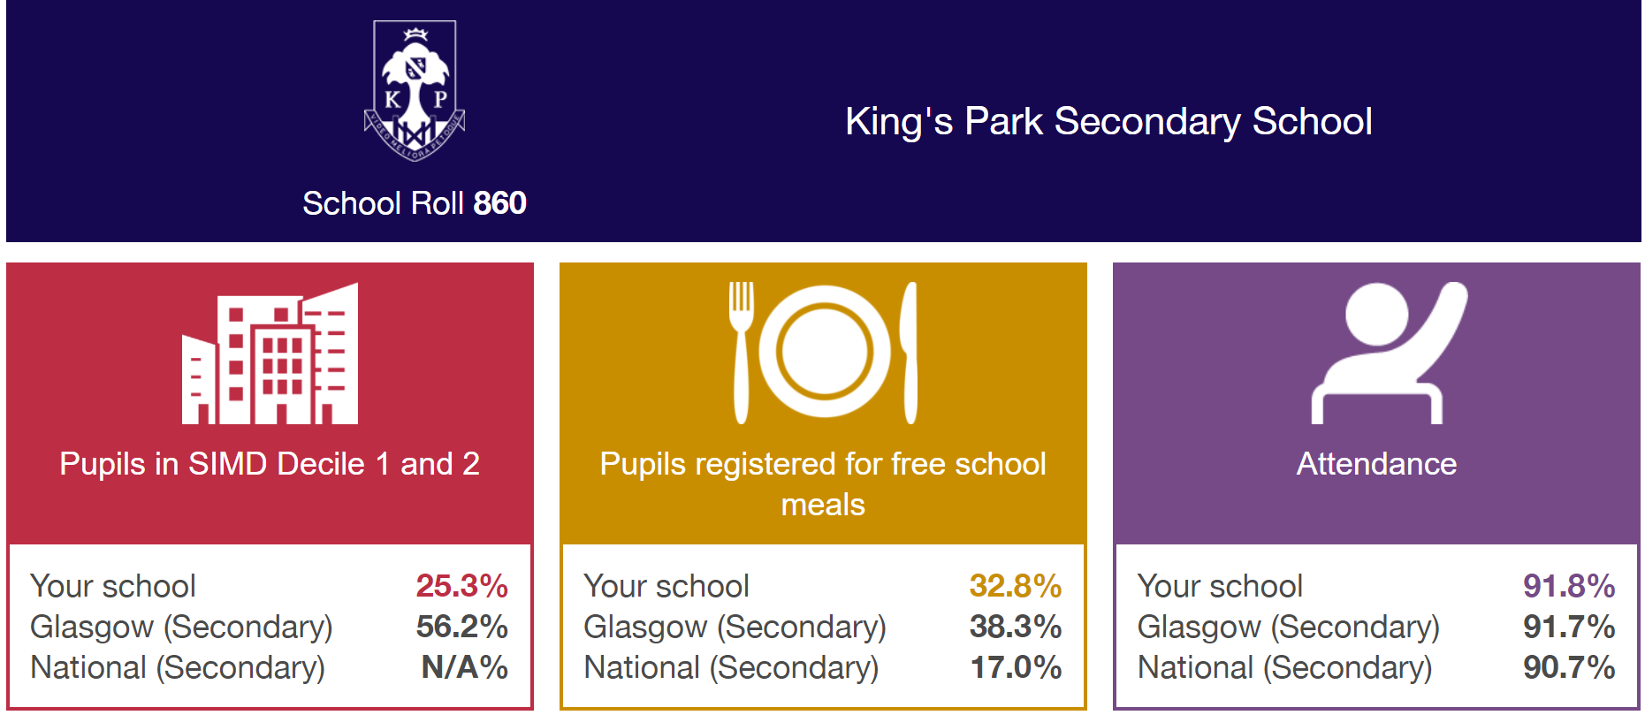
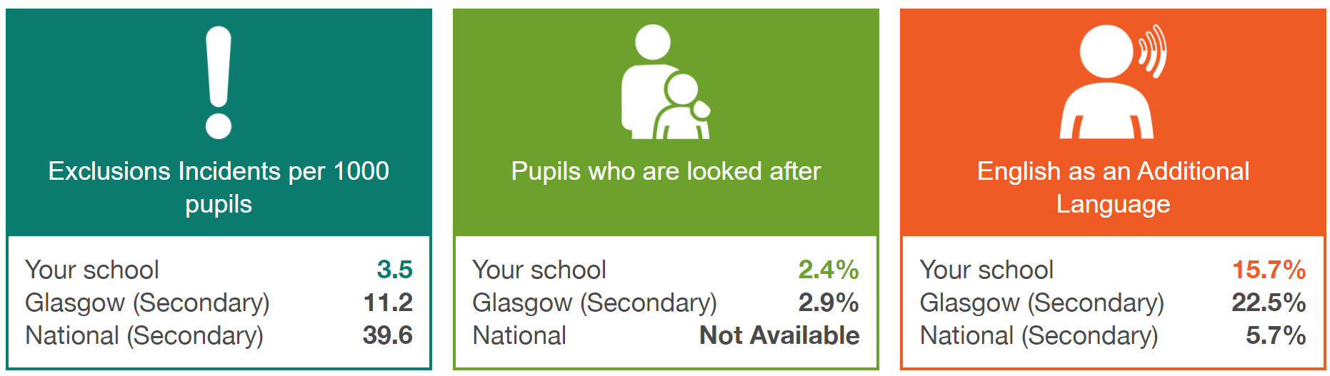

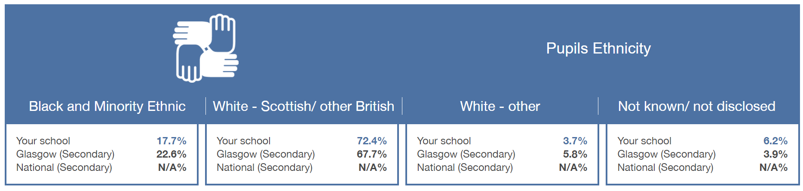

Appendix 2 Resources, Organisations and Policies

https://www.equalityhumanrights.com/en/publication-download/technical-guidance-schools-scotland

- Revised Anti Bullying Strategy 2019 [2Mb].

www.respectme.org.uk Anti-bullying service

www.crer.scot Coalition for Racial Equality and Rights

www.enableglasgow.org.uk Works with people in Glasgow with disabilities and their carers

www.glasgowwomensaid.org.uk Supporting women, children and young people experiencing domestic abuse

www.gda.scot Glasgow based charity run by and for disabled people

www.lgbtyouth.org.uk Supports LGBT young people

www.tie.scot LGBT inclusive education charity

www.stephenlawrenceday.org Stephen Lawrence Foundation website

We will continue to add to this list over time.

