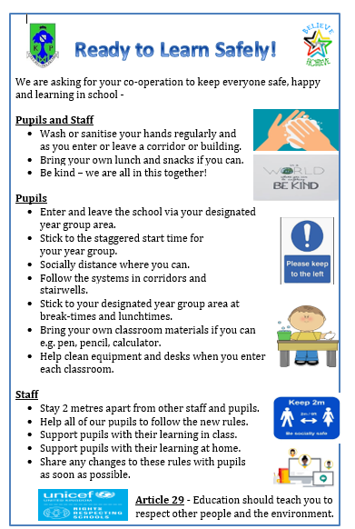

**Where to go on your first day at 8:40am -**

**S3 will enter and exit via the PE pathway on Carmunnock Road at 8.40am**

**S2 will enter and exit via the delivery entrance gate on Fetlar Drive at 8.40 am**