King’s Park Secondary School

Handbook
(Last updated November 2019)

WELCOME TO KING’S PARK SECONDARY
An Introduction by the Head Teacher:

We hope that this school handbook gives you helpful information about our school, and that you find it useful.

A school handbook is quite a formal publication, and we follow Glasgow’s guidelines about the content. However, you might also like to look at our school website and twitter feed which has up-to-date information, as well as some photographs of our school community at work: www.kingspark-sec.glasgow.sch.uk.
In King’s Park Secondary, we are committed to building on the good work which takes place in the primary schools. In fact we work with many partners – pupils, parents, staff in King’s Park Secondary, staff in the other schools in King’s Park Learning Community, partner agencies and other services.

Our purpose is to make sure that our pupils achieve the highest possible success - be that academically or through wider school achievements.
Above all, we have high standards and high expectations in all areas of our school - work ethic, behaviour, attendance, uniform and timekeeping.

If you would like to meet me, or would like a tour of our school, I would be delighted to welcome you.

Contact me so that we can make arrangements.

Kind Regards
Mrs Kirsty Ayed, Head Teacher

SCHOOL VISION and VALUES

During session 2015-2016, staff and pupils worked together to create a new motto for our school. Furthermore, one of our pupils designed our logo, with all the house colours included. Pupils and staff decided together that it would be:

“Believe, Achieve.”

Our vision is to continue to further raise expectations for all stakeholders and to raise attainment and achievement. We are keen to develop pupils’ skills and resilience to ensure that they are well prepared for the demands of living in the 21st Century.

We want King’s Park Secondary to thrive as an ambitious, vibrant, caring community of learners and responsible citizens, always working in partnership with others to improve and to meet the needs of every learner, where resources, knowledge and skills are shared and used wisely, and achievements are shared and celebrated.

Pupils in S1 – S3 are awarded Believe, Achieve merits. This helps to promote our positive approach to relationships and behaviour and gives pupils an opportunity to be rewarded for different successes both inside and outside of school.

School Information

King’s Park Secondary School is a six year non-denominational school for boys and girls. The address of the school is as follows:

King’s Park Secondary School 14, Fetlar Drive
Glasgow G44 5BL

Tel: 0141 582 0150
Fax: 0141 582 0151
Email: headteacher@kingspark-sec.glasgow.sch.uk
Website: www.kingspark-sec.glasgow.sch.uk
Twitter: KPSS@KingsParkSec

The current roll is 790

S1 | S2 | S3 | S4 | S5 | S6 | Total
154 | 149 | 147 | 138 | 139 | 69 | 796
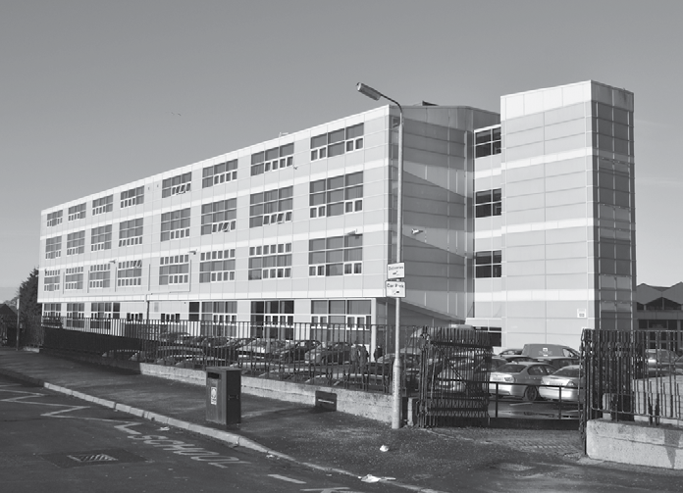

School Staff

A full list is available on the school website.

The leadership team is as follows:

Name | Role | Further information
Mrs Kirsty Ayed | Head Teacher
Mrs Ruth Kelly | Depute Head Teacher | Arran House
Mr Alison Thyne | Depute Head Teacher | Lewis House
Mrs Pauline Carr | Depute Head Teacher | Mull House
Mrs Ali Preston | Acting Depute Head Teacher | Skye House

Moving from Primary to Glasgow Secondary

We recognise that the move from primary to secondary is a very important event for young people. We have a close and effective partnership with each of the primary schools within our Learning Community – Croftfoot Primary, King’s Park Primary, Mount Florida Primary, Merylee Primary and Toryglen Primary. This ensures that the move from primary to secondary is as smooth as possible for young people.

We welcome families from outwith our area. Families living outwith the school catchment area are welcome to make a placing request to attend Glasgow Secondary. Prospective parents are welcome to visit the school and should contact the school office.

Further information is available on https://www.glasgow.gov.uk/index.aspx?articleid=18426

The School Day

Session 2019-2020

The school operates the timetable as a 33 period week with six or seven teaching periods each day. Mondays, Tuesdays and Wednesdays are 7 period days with a 15.35 finish. Thursdays and Fridays are 6 period with a 14.45 finish.

The timing of these periods is as follows:

 | Mon | Tues | Wed | Thurs | Fri
 | 8.50 am | 8.50 am | 8.50 am | 8.50 am | 8.50 am
8.50–9.40 | p1 | p1 | p1 | p1 | p1
9.40–10.30 | p2 | p2 | p2 | p2 | p2
 | INTERVAL – 10.30 – 10.45
10.45–11.35 | p3 | p3 | p3 | p3 | p3
11.35-12.25 | p4 | p4 | p4 | p4 | p4
 | LUNCH – 12.25 – 13.05
13.05-13.55 | p5 | p5 | p5 | p5 | p5
13.55-14.45 | p6 | p6 | p6 | p6 | p6
14.45-15.35 | p7 | p7 | P7

ABSENCE and TIMEKEEPING

When your child is absent from school, please phone the Absence Reporting Line on: 0141 287 0039.
When they return to school, they should give a note to our Education Liaison Officer, or the school office.
If a pupil requires permission to be out of school, the Absence Reporting Line should also be contacted. They will liaise with the school.

School Dress Code: Uniform

Pupils in King’s Park Secondary are expected to wear school uniform as this helps to create an ethos of belonging to and pride in the school and promote the identity of the school in the local community. In addition, the wearing of a uniform helps to strengthen security as pupils are easily identifiable, enabling staff to identify and approach visitors more readily.
The uniform is black and white and consists of:
- Black blazer
- White school shirt or school blouse which buttons at the collar
- School tie (available from the School Office) which must be tied properly and visible at all times
- Black school cardigan, black school jumper or black school sweatshirt
- Black school trousers or black school skirt (box pleat, knee length)
- Black school shoes or plain black boots suitable for school
Pupils will be asked to remove items of clothing advertising brand names or which conceal the school tie.
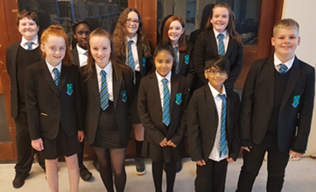

KIT FOR PHYSICAL EDUCATION

It is important that pupils come prepared to learn and for PE this requires appropriate clothing. All jewellery should be removed. Pupils who are not participating in PE must have a note or a medical certificate. Pupils who are unable to participate in practical PE should still bring their kit to allow them to assist in the lesson. This ensures that they are still able to take part in some way in the work of the class and do not miss out on the knowledge and understanding of the course.
The recommended kit is:
Training shoes, white, black or navy t-shirt/top, shorts or track suit bottoms and socks. A towel should also be brought.
There are forms of dress that are unacceptable in school, such as items of clothing which:
- Potentially encourage factions (such as football colours)
- Could cause offence (such as anti-religious symbolism or political slogans)
- Could cause health and safety difficulties (such as loose fitting clothing, jewellery)
- Could cause damage to flooring
- Carry advertising particularly for alcohol or tobacco
- Could be used to inflict damage on other pupils

Clothing & Footwear Grants

Parents/Carers receiving Income Support, Job Seekers Allowance (Income Based), Working Tax Credit (with a total annual income of less than £15,860*), Housing Benefit, Council Tax Benefit or Universal Credit (where the total income is less than £7,320) will normally be entitled to monetary grants for footwear and clothing for their children. Information and application forms may be obtained from schools and at
https://www.glasgow.gov.uk/index.aspx?articleid=17885
School meals

The catering facilities in King’s Park Secondary School are very good and are available on a cafeteria basis with facilities for snack/fast food and set meals.

In the Fuel Zone, pupils may pay by cash, Q-card or Young Scot Card which they can charge with credit by using the cash machines in the foyer of the school. They then use the cards to purchase food.

The Fuel Zone is open from 8am offering a variety of breakfast options. At the morning interval various hot and cold snacks are available. Snacks and soft drinks are available from vending machines located in the dining area. Water is freely available to pupils at all times.

Pupils may eat packed lunches in the Fuel Zone, or other designated area, but may not bring in food that has been purchased at local fast food shops.

Children who are entitled to a free lunchtime meal have their cards automatically credited every day with an allowance equivalent to the cost of a main meal. They can use their free meal allowance at any time that day, to buy hot or cold snacks or drinks, as an alternative to a main meal. We strongly encourage families who are entitled to a free meal to claim this allowance. Applications can be obtained from the Grants Section at Education Services headquarters, or from the school.

In addition, the school runs a Breakfast Club that runs from 8am every morning within the Pupil Support Department. Breakfast is provided at no cost to pupils.

Children and young people of parents/carers receiving Income Support, income-based Job Seekers Allowance, Working Tax Credit (where income is less than £7,920*), Child Tax Credit only (where income is less than £16,500*), Universal Credit (where income is less than £7,320) and income-related Employment and Support Allowance are entitled to a free midday meal. Information and application forms for free school meals may be obtained from schools and at https://www.glasgow.gov.uk/index.aspx?articleid=17885

Special dietary needs can be accommodated by contacting the School Office.

Medical and HealthCare

NHS Greater Glasgow and Clyde conduct a programme of health care for pupils in secondary school including immunisation.

Should a child become ill during the school day, a parent or designated person will be contacted and asked to collect them to take them home. It is therefore essential that the school be given an emergency contact number. If a pupil requires hospital treatment and a parent/designated person cannot be contacted then the pupil will be taken there in the care of a member of staff.

Parents and Carers should inform the school of any medical requirements relating to their child. If a young person requires medication during the school day, parents and carers must complete the appropriate medical form. This is available, on request, from the School Office.

Information in Emergencies

We make every effort to maintain a full education service, but on some occasions circumstances arise which lead to disruption. Schools may be affected by, for example, severe weather, and temporary interruption of transport, power failures or difficulties of fuel supply. In such cases we shall keep you informed by using texts, social media, the local media and letters etc.

Please ensure that your child is aware of the arrangements you have made for them in the rare event that the school should have to shut in an emergency.

It is also imperative that all parent/carer contact details are correct and if there are any change in contact details that the school office informed as soon as possible.

Data Protection – use of information about children and young people and parents/carers

We collect information about children and young people attending school (and also about parents/carers, emergency contacts etc. provided in the annual data check) to allow us to carry out the Council’s functions as the education authority for the City of Glasgow. This may sometimes involve releasing personal information to other agencies and other parts of the Council, particularly in relation to child protection issues or criminal investigations, and it may also be used for research purposes (see the link below for more details regarding this).

Information held by the school is, in legal terms, processed by Glasgow City Council. The Council is registered as a data controller under the Data Protection Act 2018 and all personal data is treated as confidential and used only in accordance with the Data Protection Act, the General Data Protection Regulations, and the Information Use and Privacy Policy approved by the City Council. For more information on how we use personal information, or to see a copy of the Information Use and Privacy Policy, see
https://www.glasgow.gov.uk/index.aspx?articleid=18010

Education specific privacy statements can be accessed at https://www.glasgow.gov.uk/index.aspx?articleid=22069.

Support for Pupils

In King’s Park Secondary, there are four Principal Teachers of Pupil Support who provide personal support for pupils throughout their school career. Each of the Principal Teachers work in partnership with one of the Depute Heads in supporting pupils in each of the House Groups – Arran, Lewis, Mull and Skye.

The Pupil Support Principal Teachers monitor pupils’ attendance, timekeeping and progress and act as parents’ first point of contact with the school.

The Principal Teachers of Pupil Support are happy to meet with parents by appointment, or to discuss any issues by phone. Due of the teaching commitments of the Pupil Support staff, parents are asked to contact them to make a suitable appointment to visit.

PT Pupil Support Yvonne Frater/Stacey Armour Arran House
PT Pupil Support Fiona McTaggart Lewis House
PT Pupil Support Anna Gibson Mull House
PT Pupil Support Ian Samson Skye House
PT Pupil Support Lorain Bertolini All Houses
5
PUPILS WITH ADDITIONAL SUPPORT NEEDS

The school has a duty to ensure that all pupils have equal access to the curriculum, with appropriate support for their needs where required.

There is close liaison between Pupil Support staff and the partner Primaries to identify pupils likely to have additional learning needs. Staff are made aware of the additional learning needs of pupils. These needs are met by focused classwork or by input from Pupil Support or English as an Additional Language teachers. A number of different strategies may be used to support pupils including specially prepared teaching materials, co-operative teaching, and individual tuition. S5 and S6 pupils help S1 pupils to develop their reading skills through a programme of paired reading. In addition, some S6 pupils provide in-class support for pupils.

There is a Principal Teacher of Pupil Support, a Teacher of English as an Additional Language, a Support Teacher and three Pupil Support Workers. Psychological Services support school staff by providing assessments and learning strategies where appropriate.
We are fully committed to meeting the needs of all pupils and hold regular meetings at which we plan for those who might benefit from additional support. Full discussion is held with parents and carers and outcomes are planned and agreed in partnership.

Further information relating to additional support needs is available on the Glasgow City Council Website https://www.glasgow.gov.uk/index.aspx?articleid=18941

Information on the Glasgow City Council’s Parental Involvement Strategy can also be found at https://www.glasgow.gov.uk/index.aspx?articleid=17870

If parents wish to discuss their child’s additional learning needs, they should, in the first instance, contact the appropriate member of the Pupil Support staff.

Any parent or carer seeking further advice regarding this policy should contact the Head Teacher in the first instance.

In sessions 2017 - 2018, we established a Nurture Base within the school to support pupils further.
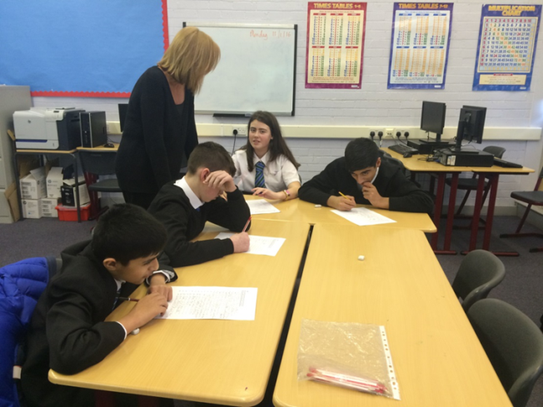

WELLBEING
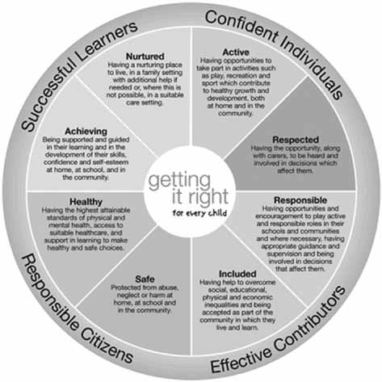
The strong links that exist between health and wellbeing, on the one hand, and achievements in learning on the other, are widely recognised in King’s Park Secondary School. Effective learning supports positive health and wellbeing, and good levels of health and wellbeing support effective learning. The impact of this inter-dependency on long-term health and social outcomes is most acutely played out in the crucial developmental period from early childhood through to the teenage years. That is when we can make the most positive impact and that is why we have such a core focus on children’s and young people’s health and wellbeing in key national policies such as Getting It Right for Every Child (GIRFEC) and Curriculum for Excellence.

The Named Person

As part of the Children and Young and People Act (Scotland) 2014, Getting it Right for Every Child (GIRFEC) is the Scottish Government –led approach to making sure that our children and young people – and their parents or carers – can get all the help they need from birth right through to age 18 (or beyond if still in school).

The vast majority of Scotland’s children and young people get the love and support they need from within their families and their wider, local communities. But even the most loving and caring families can sometimes need extra help and support. The GIRFEC approach aims to make it as easy as possible for any child or young person (and their parents) to get that help or support if they need it.

To provide that support when needed, every child in Scotland has a named individual, the Named Person, as a single point of contact. This Named Person has a responsibility to provide help and support when asked and can draw together other services if needed, coordinating help for the child or parents or carers. Please do not hesitate to contact your child’s Named Person at any time.

The Named Person in King’s Park Secondary School is your child’s Pupil Support Teacher. Your child will be informed of the name of their individual Named Person.

PROMOTING POSITIVE BEHAVIOUR AND RELATIONSHIPS

Children’s Rights, as outlined in the UNCRC (United Nations Convention on the Rights of the Child) are fundamental to a good school ethos. Adults in King’s Park Secondary will work with young people to ensure that they are aware of their rights and fully respect the rights of others.

Most pupils enjoy coming to school and wish to learn. They behave and relate well to staff and other pupils. If pupils misbehave in a minor way, staff will respond in a firm, supportive manner to help them realise the mistake so that it will not occur again. This firm, supportive control is necessary both in and out of the classroom so that education can proceed uninterrupted. Our policy is one which encourages positive behaviour and points out the benefits of behaving well.

In any large school there is a small number of less well-behaved pupils who need more formal discipline. This will usually involve parents to whom we look for support in helping to improve behaviour. Mostly, once the pupil realises that school and home are working together, improvement in behaviour occurs.

If misbehavior is more serious, senior staff are involved, starting with Principal Teachers of subjects, then Principal Teachers of Pupil Support and progressing to Depute Head Teacher or Head Teacher according to the seriousness or frequency of offences. In some cases, the Education Authority and/or other partner agencies may be involved.

Every pupil is issued with the document ‘What We Expect of All Our Pupils’. The rules are simple and based on common sense and courtesy. Pupils are given every encouragement to comply with ‘What We Expect of All Our Pupils’ and this is linked to our Discipline System. However, a pupil who continually misbehaves will be subject to the discipline procedures which are part of our Promoting Positive Behaviour and Relationships Policy. At every stage, the pupil is given opportunities to reflect on his/her behaviour and to take steps to improve it. The system stresses the valuable contribution made by the early involvement of parents and the counselling role of Pupil Support staff. When parents and school work together, this has been shown to produce the most benefit to pupils.

To summarise, if a pupil continually misbehaves then:

- his/her parents will be informed
- he/she may be temporarily removed from a class or classes
- he/she may be removed from all classes and accommodated for a period of time in the Internal Exclusion facility.
- as a last resort, the pupil may be excluded from school

An adult presence is provided in the playground and pupil social areas at break times to promote positive behaviour
Promoting Positive Behaviour and Relationships –
Applying the Nurturing Principles across the whole school

At King’s Park Secondary School, we have a Nurture Base, to help some of our pupils settle more easily into the school day. Pupils attend the base every morning, period one, a Friday period six and two other times throughout the week. They work with our Principal Teacher of Pupil Support, our designated Nurture Teacher, and our Support for Learning Workers. Pupils are identified by House Depute Head Teachers and Principal Teachers of Pupil Support.

We also are working towards becoming a Nurturing School – which means that we apply the six Nurture Principles to everything that we do.

The six principles are:
1. Children's learning is understood developmentally
2. The classroom offers a safe base
3. The importance of nurture for the development of wellbeing
4. Language is a vital means of communication
5. All behaviour is communication
6. The importance of transition in children's lives
Ref: Lucas,S., Insley,K. and Buckland,G. (2006) Nurture Group Principles and Curriculum Guidelines Helping Children to Achieve, The Nurture Group Network.

If you want to know more about how we do this, please do not hesitate to contact the school.
Rights Respecting School Award
Throughout the course of this session, we are continuing our Rights Respecting School Award. This Award recognises achievement in putting the UN Convention on the Right of the Child (UNCRC or CRC) into practice in your school to improve well-being and help all children and young people realise their potential.

There are four key areas of impact for children at a Rights Respecting school; wellbeing, participation, relationships and self-esteem.

The difference that a Rights Respecting school makes goes beyond the school gates, making a positive impact on the whole community. In King’s Park Secondary, we believe that every person in our school community is important. Working towards the Rights Respecting School Award helps us to celebrate and promote diversity and inclusion. We have included key dates and events in our school calendar to help us recognise and learn more about different groups of people:

Month | Event
October | - Black History Month  - Coming out Day  - World Mental Health Day
November | - National Anti-Bullying Week
December | - World Aids Day  - Int. Human Rights Day  - Equality and Diversity Day
January | - HMD
February | - LBGT History Month
April | - World Autism Day
May | - Int. day against Homo/Bi/Trans phobia
June | - Gypsy, Roma and Traveller History Months  - World Refugee Day

If you want to know more about this Award, please do not hesitate to contact the school.

What We Expect of All Our Pupils

Achieve your full potential in your school work

- By working hard and behaving well in all your classes.
- By taking a pride in the presentation and accuracy of all your written work.
- By listening carefully and taking part in class discussion.
- By doing all your homework.

Take an increasing responsibility for your own work

- By coming to lessons with the appropriate equipment and books.
- By aiming for full attendance at school.
- By being punctual to school and class.
- By setting yourself targets to achieve and monitoring your own progress.
- By developing good study habits and study skills.

Consider the needs of others

- By treating people as you would like to be treated.
- By making sure you do not disrupt the education of others.
- By moving around the school in a sensible way.

Be good ambassadors of the school both in school and out of school activities

- By dressing in school uniform.
- By being polite and considerate to all members of the school community and to
visitors.
- By taking a pride in the school environment.
- By looking after your own property and respecting the property of others.

Communication with parents/carers

At King’s Park Secondary School, we strongly encourage all parents to become involved in the education of their children. We are always ready to listen to suggestions for new ways of stimulating parental interest. We contact and involve parents in many ways. For example:
Letters – further information which requires a response may be sent out in letter form.
Text messaging – You may also receive text reminders about events/school closures/ letters issued, etc.
Twitter – we update our Twitter account regularly with information about what’s happening in our school.
Meetings - Parents and carers are welcome in the school to discuss any aspect of their child’s development and progress. To avoid disappointment, it is advisable to make an appointment. There are various opportunities throughout the year when parents can discuss their child’s progress with school staff.
School website – will contain a great deal of information about the school. It is a good idea to check this regularly.
Newsletters – will be sent out on a regular basis to keep parents and carers informed about the work of the school.
Parents and carers are welcome at other events throughout the school year e.g. workshops, information evenings, focus groups, award ceremonies, religious and other assemblies. The school newsletter and website will keep you informed.

Strong communication links between home and school ensure parents and carers are confident to address any concerns they may have about their child’s education with Pupil Support Staff and the Senior Leadership Team.
Appointments During School Hours

If your child has an unavoidable appointment, please give them a letter for their Pupil Support teacher to ensure that they have permission be absent from class.

Comments & Complaints

In Glasgow Secondary School we aim to have positive relationships across our school community. However, if you have a comment or complaint about any aspect of school life, please contact the Headteacher in the first instance.

Glasgow City Council complaints procedures are available:
https://www.glasgow.gov.uk/index.aspx?articleid=16133

Customer Care Team
Customer & Business Services
Glasgow City Council
City Chambers
Glasgow G2 1DU

Tel: 0141 287 0900
e-mail: customercare@glasgow.gov.uk or education.customerservices@glasgow.gov.uk

Transport
The Education Authority has a policy of providing free transport to all secondary pupils who live out with a certain radius from their local school by the recognised shortest walking route. This policy is more generous than the law requires. This means that the provision of transport could be reviewed at any time. Parents/Carers who consider they are eligible should obtain an application form from the school or at https://www.glasgow.gov.uk/index.aspx?articleid=17882

King’s Park Secondary Parent Forum and Parent Partnership

The Scottish Schools (Parental Involvement) Act 2006 has changed the arrangements for parental representation in all schools. Since August 2007, all parents/carers are automatically members of the Parent Forum for their school and they have a right to establish a Parent Council to represent them.

Parent Forum

The membership of the Parent Forum is made up of all parents/carers who have a child at an education authority school. Membership of the Parent Forum allows parents/carers to have a say in the local arrangements to enable their collective view to be represented on matters such as the quality and standards of education at the school and other matters of interest to parents. One of the ways parents/carers in the Parent Forum will be able to express their views will be through the Parent Partnership.

Parent Partnership

The Parent Partnership is a group of parents selected by members of the Parent Forum to represent all the parents/carers of children at the school. Parent Councils are very flexible groups and the Parent Forum can decide on the type of group it wants to represent their views. The type of things a Parent Council could get involved in includes:

- supporting the work of the school;
- gathering and representing parents’/carers’ views to the Head Teacher, education authority and Education Scotland;
- promoting contact between the school, parents/carers, pupils and the local community;
- involvement in the appointment of senior school staff.
- Fundraising.

Minutes of the Parent Partnership are available on the school website.

Parents who would like to join the group would be made most welcome. Please contact the school or e-mail us directly: kpssparentpartnership@gmail.com
RELIGIOUS OBSERVANCE

King’s Park Secondary is fortunate to have close links with a number of local churches. The ministers of these churches (The Chaplaincy Team) provide opportunities at House Assemblies for religious observance. Parents have the right to withdraw their child from religious observance and should inform the school in writing.

Parents and carers from religions other than Christianity may request that their children be permitted to be absent from school in order to celebrate recognised religious events. Only written requests detailing the proposed arrangements will be considered. Appropriate requests will be granted on up to three occasions (days) in any one school session and the pupil noted in the register using code REL on those days.
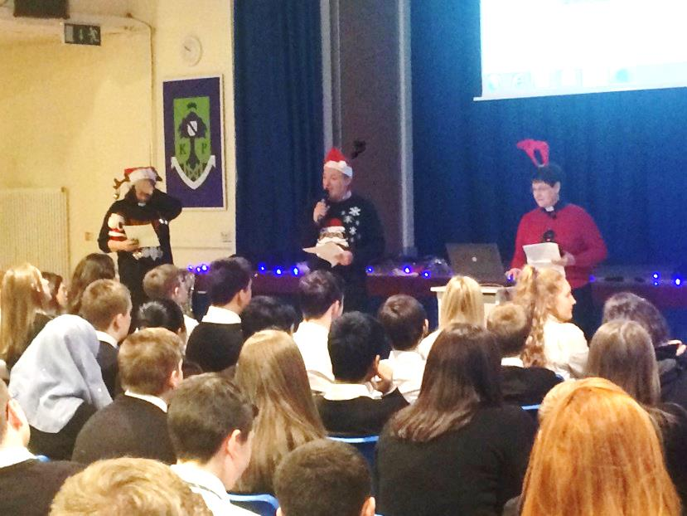

Assessment & Reporting

All young people are assessed both formally and informally throughout the school year. This allows young people and their teachers to identify their strengths and areas for improvement. A variety of assessment methods are used to enable staff to pass on information to parents and carers about the progress of their child. Assessment records are kept by teachers and form the basis of discussion at parents’ meetings throughout the year.

Dates of all parents’ meetings and the schedule for issuing written reports is included in the school calendar, which is issued at the start of term and is available on the website.

If you have any concerns about your child’s progress do not hesitate to contact their Pupil Support teacher at any time.

Pupil Profiles

All S3 learners have a profile which reflects their progress in learning and achievement and emphasis their strengths. The profile documents their key achievements in school, at home and in the community and the content is decided by the young person. The profile provides a valuable way for learners to share information about their achievements with their parents, teachers and in the future, staff in colleges, universities and employers. The profile also supports the move from S3 into the senior phase of secondary school.

Homework

Regular, effective homework is an important part of the school day. We use ‘Show my Homework’ which is an online homework facility where teachers issue homework while pupils and parents can access the details through a PC or suitable device. Parents are asked to check this on a regular basis. Homework has many advantages:

- It reinforces work done in class.
- It develops good study habits and a sense of personal discipline.
- It develops areas of interest that can be followed up later in life and become a leisure pursuit.
- It allows parents to see, help and become involved in their child’s work.

The amount of homework varies in length, nature and frequency depending on the subject. The amount of homework will increase as your child progresses through the school.

Supported Study

This is an important initiative which allows pupils to attend additional classes during lunchtimes, after school and during holiday periods. Large numbers of our staff give generously of their time in this area. Subjects on offer will depend on the staff available to deliver. Pupils will be kept informed of the arrangements.

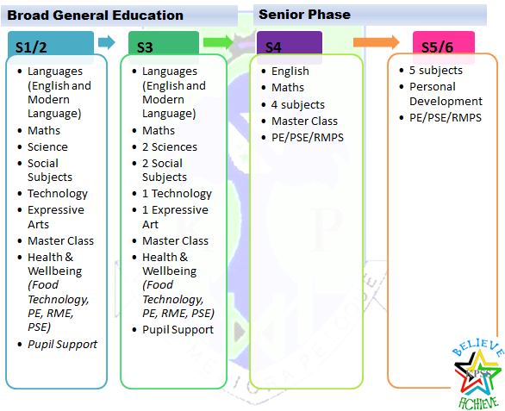
CURRICULUM DESIGN AND PLAN

The School Year Session 2020-2021 – Holidays
Return to school: Monday 6th January 2020

Second mid-term: Friday 7th and Wednesday 12th February 2020;
Return date for pupils: Thursday 13th February 2020

Spring Holiday (Easter)
- Schools close at 2.30pm on Friday 3rd April
- Good Friday 10th April
- Easter Monday 13th April
- Schools return on Monday 20th April

May Weekend:
- Friday 8th May (May Holiday)
- Monday 11th May (In-Service Day)
- Friday 22nd and Monday 25th May (May Weekend)
Schools close: 1pm Tuesday 24th June 2020
Return date for pupils: Thursday 13 August 2020

School Improvement

On an annual basis, you will receive a copy of our Standards and Quality report. The report will be used to share the overall exam performance of the school and highlights progress in key curricular areas.

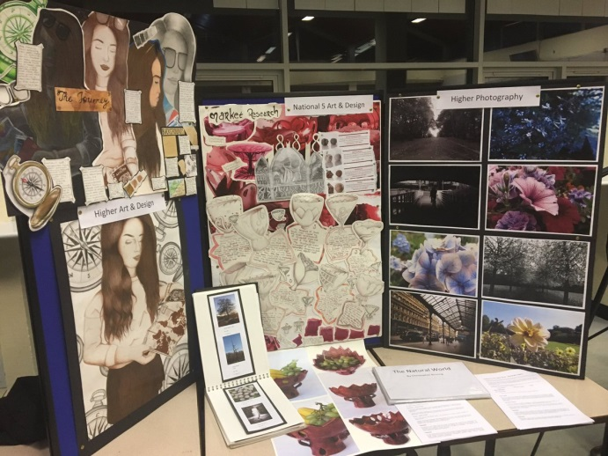
Our priorities for improvement are detailed in our School Improvement Plan which is discussed with our Parent Partnership. Any parent or carer seeking a copy of the plan should contact the school office or access it via the school website.

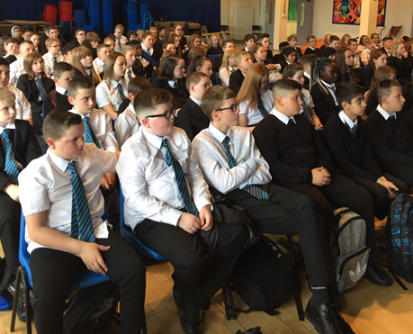

Useful addresses and Contacts

Education Services Glasgow City Council City Chambers, East 40 John Street Glasgow G1 1JL.

Telephone: 0141 287 5758

Executive Director of Education - Maureen McKenna Skills Development (Scotland)
Newlands Careers Centre 8 Coustonholm Road Glasgow G43 1SS
Telephone: 0141 429 1999 Glasgow Life
20 Trongate
Glasgow G1 5ES
Letting Section phone: 0141 302 2814/2815 Local Councillors (Ward 1 - Linn)
Lord Provost Eva Borland
Cllr Euan Blockley
Cllr Malcolm Cunning
Cllr Glen Elder
Cllr Margaret Morgan

c/o Glasgow City Council City Chambers
George Square Glasgow G2 1DU.
Telephone: 0141 287 2000

