King’s Park Secondary School

School Handbook

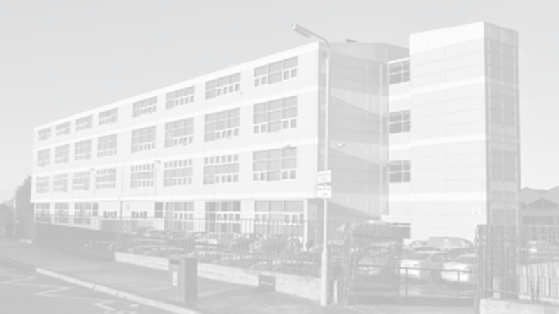

(Last updated October 2023)
Contents
SCHOOL WELCOME TO KING’S PARK SECONDARY 5
SCHOOL VISION and VALUES 6
SCHOOL INFORMATION 6
SCHOOL STAFF 8
MOVING FROM PRIMARY TO SECONDARY 8
THE SCHOOL DAY 9
PUPIL ABSENCE 9
APPOINTMENTS DURING SCHOOL 9
SCHOOL UNIFORM 10
KIT FOR PHYSICAL EDUCATION 11
CLOTHING AND FOOTWEAR GRANTS 11
INFORMATION IN EMERGENCIES 11
SCHOOL MEALS 12
MEDICAL AND HEALTHCARE 12
PARENTPAY 13
DATA PROTECTION 14
SUPPORT FOR PUPILS 15
PUPILS WITH ADDITIONAL SUPPORT NEEDS 15
ADDITIONAL LEARNING NEEDS DEPARTMENT 16
WELLBEING 16
CHILD PROTECTION AND SAFEGUARDING 16
PROMOTING POSITIVE BEHAVIOUR AND RELATIONSHIPS 17
APPLYING THE NURTUREING PRINCIPLES ACROSS THE WHOLE SCHOOL 18
RIGHTS RESPECTING SCHOOLS AWARD 19
WHAT WE EXPECT OF ALL OUR PUPILS 20
COMMUNICATION WITH PARENTS/CARERS 21
TRANSPORT 21
PARENT FORUM AND PARENT PARTNERSHIP 22
YOUTH PARLIAMENT 22
RELIGIOUS OBSERVANCE 23
ASSESSMENT & REPORTING 23
S3 PUPIL PROFILES 23
HOMEWORK 24
SUPPORTED STUDY 24
CURRICULUM DESIGN AND PLAN 25
SESSION 2023-24 HOLIDAYS 26
SCHOOL IMPROVEMENT 27
COMMENTS AND COMPLAINTS 28
USEFUL CONTACTS 28

SCHOOL WELCOME TO KING’S PARK SECONDARY

An introduction by our Head Teacher

We hope that this school handbook gives you helpful information about our school, and that you find it useful.

A school handbook is quite a formal publication, and we follow Glasgow’s guidelines about the content. However, you might also like to look at our school website and twitter feed which has up-to-date information, as well as some photographs of our school community at work: www.kingspark-sec.glasgow.sch.uk.

In King’s Park Secondary, we are committed to building on the good work which takes place in the primary schools. In fact we work with many partners – pupils, parents, staff in King’s Park Secondary, staff in the other schools in King’s Park Learning Community, partner agencies and other services.

Our purpose is to make sure that our pupils achieve the highest possible success - be that academically or through wider school achievements.

Above all, we have high standards and high expectations in all areas of our school - work ethic, behaviour, attendance, uniform and timekeeping.

If you would like to meet me, or would like a tour of our school, I would be delighted to welcome you.

Contact me so that we can make arrangements.

Kind Regards

Mrs Kirsty Ayed
Head Teacher

SCHOOL VISION and VALUES

During session 2015-2016, staff and pupils worked together to create a new motto for our school. Furthermore, one of our pupils designed our logo, with all the house colours included. Pupils and staff decided together that it would be:

“Believe, Achieve.”

We revisited this motto with young people and staff in Session 2021/22 and agreed our vision remains to continue to further raise expectations for all stakeholders and to raise attainment and achievement. We are keen to develop pupils’ skills and resilience to ensure that they are well prepared for the demands of living in the 21st Century.

We want King’s Park Secondary to thrive as an ambitious, vibrant, caring community of learners and responsible citizens, always working in partnership with others to improve and to meet the needs of every learner, where resources, knowledge and skills are shared and used wisely, and achievements are shared and celebrated.

Pupils in S1 – S3 are awarded Believe, Achieve merits. This helps to promote our positive approach to relationships and behaviour and gives pupils an opportunity to be rewarded for different successes both inside and outside of school.

SCHOOL INFORMATION

King’s Park Secondary School is a six-year non-denominational school for boys and girls. The address of the school is as follows:

King’s Park Secondary
14 Fetlar Drive
Glasgow
G44 5BL

Tel: 0141 582 0150
Email: headteacher@kingspark-sec.glasgow.sch.uk
Website: www.kingspark-sec.glasgow.sch.uk
Twitter: KPSS@KingsParkSec

The current roll is 906.

S1 | S2 | S3 | S4 | S5 | S6 | Total
165 | 166 | 175 | 174 | 135 | 91 | 906

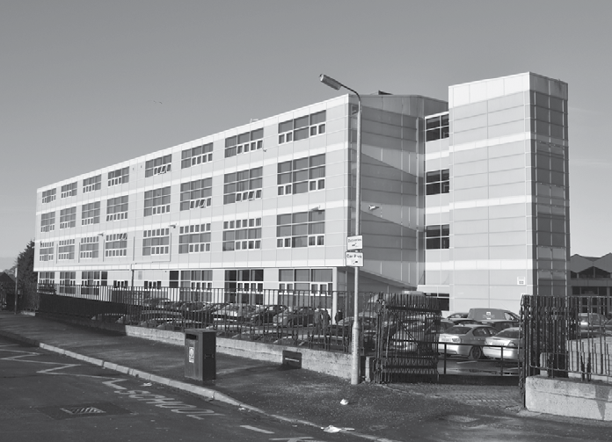

SCHOOL STAFF

A full list is available on the school website.

The leadership team is as follows:

Name | Role
Mrs Kirsty Ayed | Head Teacher  (Depute Child Protection Coordinator)
Mrs Ruth Kelly | Depute Head Teacher | Arran House
Mrs Alison Thyne | Depute Head Teacher | Lewis House
Ms Katy Cook | Depute Head Teacher | Mull House
Mrs Ali Preston | Depute Head Teacher  (Child Protection Coordinator) | Skye House

MOVING FROM PRIMARY TO SECONDARY

We recognise that the move from Primary to Secondary is a very important event for young people. We have a close and effective partnership with each of the primary schools within our Learning Community – Croftfoot Primary, King’s Park Primary, Mount Florida Primary and Toryglen Primary. This ensures that the move from Primary to Secondary is as smooth as possible for young people.

We welcome families from outwith our area. Families living outwith the school catchment area are welcome to make a placing request to attend Glasgow Secondary. Prospective parents are welcome to visit the school and should contact the school office.

Further information is available on https://www.glasgow.gov.uk/index.aspx?articleid=18426

THE SCHOOL DAY

The school operates the timetable as a 33-period week with six or seven teaching periods each day. Mondays, Tuesdays and Wednesdays are 7 period days with a 15.35 finish. Thursdays and Fridays are 6 period days with a 14.45 finish.

The timing of these periods is as follows:

 | Mon | Tues | Wed | Thurs | Fri
 | 8.50 am | 8.50 am | 8.50 am | 8.50 am | 8.50 am
8.50–9.40 | P1 | P1 | P1 | P1 | P1
9.40–10.30 | P2 | P2 | P2 | P2 | P2
 | INTERVAL – 10.30 – 10.45
10.45–11.35 | P3 | P3 | P3 | P3 | P3
11.35-12.25 | P4 | P4 | P4 | P4 | P4
 | LUNCH – 12.25 – 13.05
13.05-13.55 | P5 | P5 | P5 | P5 | P5
13.55-14.45 | P6 | P6 | P6 | P6 | P6
14.45-15.35 | P7 | P7 | P7

PUPIL ABSENCE

Within King’s Park Secondary School good attendance is encouraged at all times to ensure pupil success. Parents and carers are asked to advise if their child is going to be absent as early as possible on the first day of absence. If the young person is going to be absent for some time, it would be helpful to know at the earliest opportunity. The school uses daily text messaging to inform parents and carers of a young person’s absence if no contact has been made. All unexplained absence is investigated by our PT Pupil Support Team and appropriate action taken. All calls must be made to the Pupil Absence Reporting Line on 0141 287 0039. The line is open between 08:00 – 15:30 Monday to Friday. Alternatively, you can use the online form on the Glasgow City Council website at https://www.glasgow.gov.uk/index.aspx?articleid=18832

APPOINTMENTS DURING SCHOOL

If your child has an unavoidable appointment, please give them a letter for their Pupil Support teacher or phone the school absence line to ensure that they have permission be absent from class.

SCHOOL UNIFORM

Pupils in King’s Park Secondary are expected to wear school uniform as this helps to create an ethos of belonging to and pride in the school and promote the identity of the school in the local community. In addition, the wearing of a uniform helps to strengthen security as pupils are easily identifiable, enabling staff to identify and approach visitors more readily. In Session 22/23 we carried out a consultation on school uniform with pupils, parents/carers and staff and based on feedback relaxed our uniform policy to include unbranded joggers, leggings and shorts. Reflecting on the cost of the school day, pupils, parents/carers and staff overwhelmingly agreed that it was important all items of clothing were unbranded to keep in mind cost and ensure greater equity amongst all young people.

The uniform is black and white and consists of:

- Black blazer (optional)
- White school shirt, school blouse or polo shirt
- School tie (available from the School Office) which must be tied properly and visible at all times
- Black cardigan, black jumper or black sweatshirt/hoodie – either with school logo or unbranded
- Black school trousers, leggings, joggers, skirt or smart shorts (unbranded)
- Black footwear

Pupils will be asked to remove items of clothing advertising brand names or which conceal the school tie.

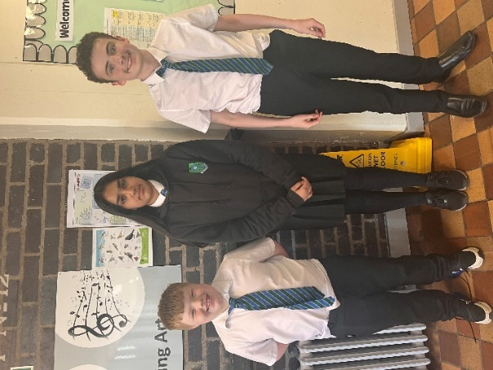

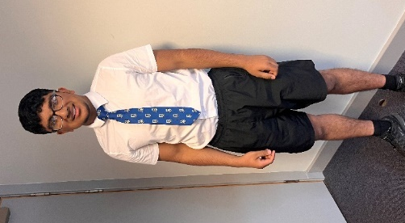
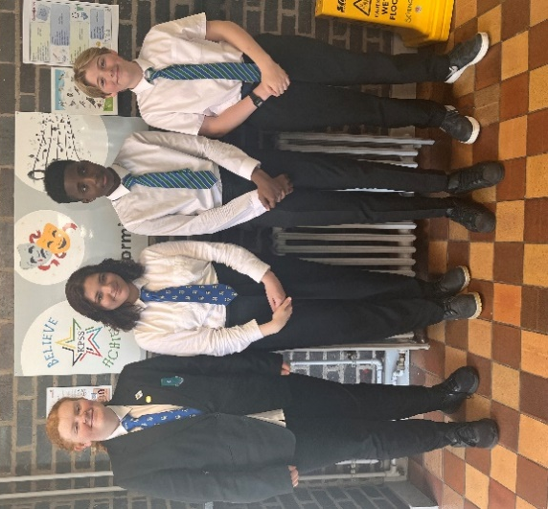

KIT FOR PHYSICAL EDUCATION

It is important that pupils come prepared to learn and for PE this requires appropriate clothing. All jewellery should be removed. Pupils who are not participating in PE must have a note or a medical certificate. Where physically possible, pupils who are unable to participate in practical PE should still bring their kit to allow them to assist in the lesson by refereeing, keeping scores or assisting with the distribution of equipment. This ensures that they are still able to take part in some way in the work of the class and do not miss out on the knowledge and understanding of the course.

The recommended kit is:

- Training shoes, white, black or navy t-shirt/top, shorts or track suit bottoms and socks.
- There are forms of dress that are unacceptable in school, such as items of clothing which:
- Potentially encourage factions (such as football colours)
- Could cause offence (such as anti-religious symbolism or political slogans)
- Could cause health and safety difficulties (such as loose fitting clothing, jewellery)
- Could cause damage to flooring
- Carry advertising particularly for alcohol or tobacco
- Could be used to inflict damage on other pupils

CLOTHING AND FOOTWEAR GRANTS

Parents/Carers receiving Income Support, Job Seekers Allowance (Income Based), Working Tax Credit (with a total annual income of less than £16,105*), Housing Benefit, Council Tax Benefit or Universal Credit (where the total income is less than £15,050) will normally be entitled to monetary grants for footwear and clothing for their children. Information and application forms may be obtained from schools and at
https://www.glasgow.gov.uk/index.aspx?articleid=17885

INFORMATION IN EMERGENCIES

We make every effort to maintain a full education service, but on some occasion’s circumstances arise which lead to disruption. Schools may be affected by, for example, severe weather, and temporary interruption of transport, power failures or difficulties of fuel supply. In such cases we shall keep you informed by using texts, social media, the local media and letters etc.

Please ensure that your child is aware of the arrangements you have made for them in the rare event that the school should have to shut in an emergency.

It is also imperative that all parent/carer contact details are correct and if there are any change in contact details that the school office informed as soon as possible.

SCHOOL MEALS

The Fuel Zone offers various hot and cold meals/snacks at morning interval and lunch time. Pupils may eat packed lunches in the designated areas; Fuel Zone, Social Space or outside at our picnic tables, but may not bring in food that has been purchased at local fast food shops into the Fuel Zone.

In addition, our FARE youth workers run a free breakfast club at 8.30am in our school canteen. Breakfast is provided at no cost to pupils.

Young people who have a free school meal entitlement are allowed use their free lunch meal allowance at interval or lunchtime to buy hot or cold snacks, as an alternative to a main meal. We strongly encourage families who are entitled to a free school meal to claim this allowance. Applications can be obtained from the Grants Section at Education Services headquarters, or from the school.

You may be eligible for Free School Meals if you receive any of the following benefits: Income Support, Job Seekers Allowance, or Employment & Support Allowance, Working Tax Credit with an annual income of less than £8,717, Universal Credit with a monthly take-home pay figure of £726 or less, Child Tax Credit, but not Working Tax Credit, with an annual income of less than £18,72, Asylum Seeker, receiving support under part VI of the Immigration and Asylum Act 1. Information and application forms for free school meals may be obtained from schools and at: https://www.glasgow.gov.uk/index.aspx?articleid=17885

Special dietary needs can be accommodated by contacting the School Office.

MEDICAL AND HEALTHCARE

NHS Greater Glasgow and Clyde conduct a programme of health care for pupils in Secondary school including immunisation.

Should a child become ill during the school day, a parent or designated person will be contacted and asked to collect them to take them home. It is therefore essential that the school be given an emergency contact number. If a pupil requires hospital treatment and a parent/designated person cannot be contacted then the pupil will be taken there in the care of a member of staff.

Parents and Carers should inform the school of any medical requirements relating to their child. If a young person requires medication during the school day, parents and carers must complete the appropriate medical form. This is available, on request, from the School Office.

PARENTPAY

Glasgow City Council have introduced an online payment platform called ParentPay into all primary and secondary schools across the city. ParentPay is used to pay for all food/drink purchases in our canteen, school trips, concert tickets, school ties etc. and has enabled us to remove all cash and cheques from schools.

How do I get started?

All parents/carers have been issued with an activation letter containing personal activation details to enable you to set up your ParentPay account. If you require an additional copy of this, please contact our school office.

If you have more than one child at a ParentPay school/s you can add them to a single account, providing one login for all children at ParentPay schools. Please activate your account as soon as possible.

What does ParentPay do?

enables you to pay for trips and other items such as tickets, uniforms, clubs etc.
offers a highly secure payment site.
gives you a history of all the payments you have made.
allows you to create a single account login across all your children that attend a ParentPay school.
shows you all items available for payment relevant to each of your children.
emails a receipt of your payment to the email address you register.
offers you the ability to set automated payment reminders.

How does ParentPay help you?

gives you the freedom to make payments to school whenever and wherever you like.
stops you having to search for cash to send to school.
allows you to set up an alert when your balance is low.
gives you peace of mind that your payment has been made safely and securely.
helps with budgeting; payments are immediate, there is no waiting for cheques to clear.
payments for many of the larger trips can be made by instalments up to the due date.
you will never need miss a payment, or have insufficient credit, with automated email/SMS alerts.
ParentPay is quick and easy to use.

How does ParentPay help our school?

reduces the administrative time spent on banking procedures.
keeps accurate records of payments made to every service for every student.
reduces paper ‘waste’.
allows for easy and quick refunds to be made back to the payment card.
improves communication between the school and parents concerning payments.
offers a more efficient payment collection process, reducing the amount of money held on school premises.

More information can be found on the ParentPay website at www.parentpay.com.

DATA PROTECTION

We collect information about children and young people attending school (and also about parents/carers, emergency contacts etc. provided in the annual data check) to allow us to carry out the Council’s functions as the education authority for the City of Glasgow. This may sometimes involve releasing personal information to other agencies and other parts of the Council, particularly in relation to child protection issues or criminal investigations, and it may also be used for research purposes (see the link below for more details regarding this).

Information held by the school is, in legal terms, processed by Glasgow City Council. The Council is registered as a data controller under the Data Protection Act 2018 and all personal data is treated as confidential and used only in accordance with the Data Protection Act, the General Data Protection Regulations, and the Information Use and Privacy Policy approved by the City Council. For more information on how we use personal information, or to see a copy of the Information Use and Privacy Policy, see:

https://www.glasgow.gov.uk/index.aspx?articleid=18010

Education specific privacy statements can be accessed at:

https://www.glasgow.gov.uk/index.aspx?articleid=22069.

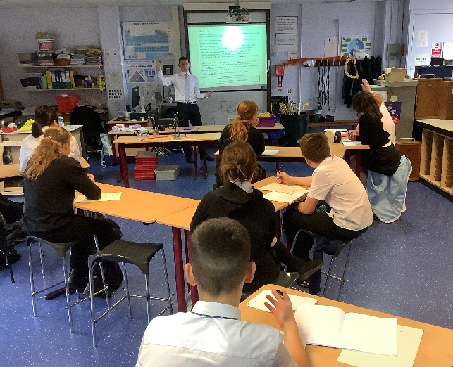
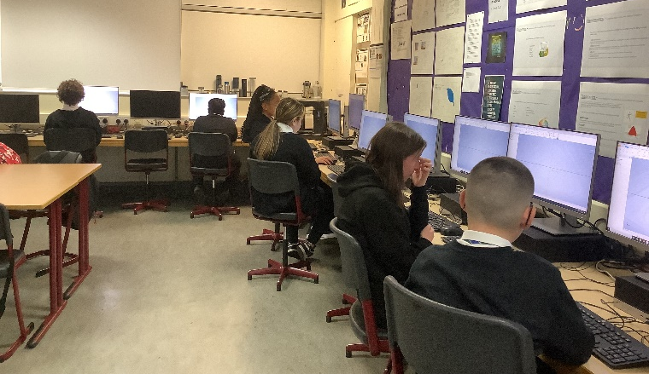
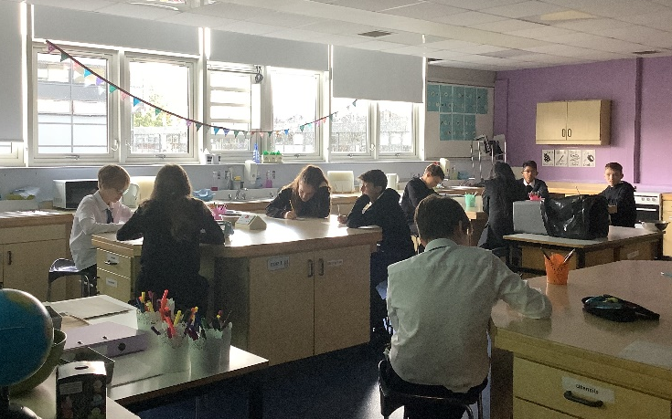
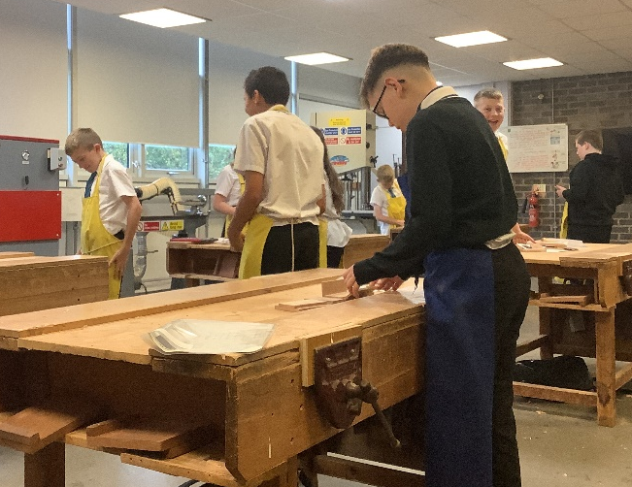

SUPPORT FOR PUPILS

In King’s Park Secondary, there are five Principal Teachers of Pupil Support who provide personal support for pupils throughout their school career. Four of the Principal Teachers work in partnership with one of the Depute Heads in supporting pupils in each of the House Groups – Arran, Lewis, Mull and Skye. In addition, Mrs Bertolini supports young people across all four Houses Groups.

The Pupil Support Principal Teachers monitor pupils’ attendance, timekeeping and progress and act as parents’ first point of contact with the school. They also monitor a holistic view of pupils’ progress and attainment.

The Principal Teachers of Pupil Support are happy to meet with parents by appointment, or to discuss any issues by phone. Due of the teaching commitments of the Pupil Support staff, parents are asked to contact them to make a suitable appointment to visit.

PT Pupil Support Arran House Miss S Armour (K McGugan – maternity leave)
PT Pupil Support Lewis House Miss F McTaggart
PT Pupil Support Mull House Ms A Gibson
PT Pupil Support Skye House Mr I Samson
PT Pupil Support All Houses Ms L Bertolini

PUPILS WITH ADDITIONAL SUPPORT NEEDS

The school has a duty to ensure that all pupils have equal access to the curriculum, with appropriate support for their needs where required.

There is close liaison between Pupil Support staff and the partner Primaries to ensure staff are aware of the additional learning needs of pupils. These needs are met by targeted classwork or by input from Pupil Support or English as an Additional Language teachers. A number of different strategies may be used to support pupils including specially prepared teaching materials, co-operative teaching, and individual tuition. S5 and S6 pupils help S1 pupils to develop their reading skills through a programme of paired reading. In addition, some S6 pupils provide in-class support for pupils.

There is a Principal Teacher of Pupil Support, a Teacher of English as an Additional Language, a Support Teacher and four Support for Learning Assistants. Psychological Services support school staff by providing assessments and learning strategies where appropriate.
We are fully committed to meeting the needs of all pupils and hold regular meetings at which we plan for those who might benefit from additional support. Full discussion is held with parents and carers and outcomes are planned and agreed in partnership.

Further information relating to additional support needs is available on the Glasgow City Council Website https://www.glasgow.gov.uk/index.aspx?articleid=18941

Information on the Glasgow City Council’s Parental Involvement Strategy can also be found at https://www.glasgow.gov.uk/index.aspx?articleid=17870

If parents wish to discuss their child’s additional learning needs, they should, in the first instance, contact the appropriate member of the Pupil Support staff.

Any parent or carer seeking further advice regarding this policy should contact the Head Teacher in the first instance.

ADDITIONAL LEARNING NEEDS DEPARTMENT

We have an additional learning needs department in King’s Park Secondary School, currently known as our Integration Centre. Mrs Ogilvie is the Principal Teacher of the Integration Centre and she, alongside six classroom teachers and six Support for Learning Workers work closely with the young people in their care. Their role is to help them to develop skills for learning and preparing them for their transition from school to ensure they are ready for work or going into further education.

WELLBEING

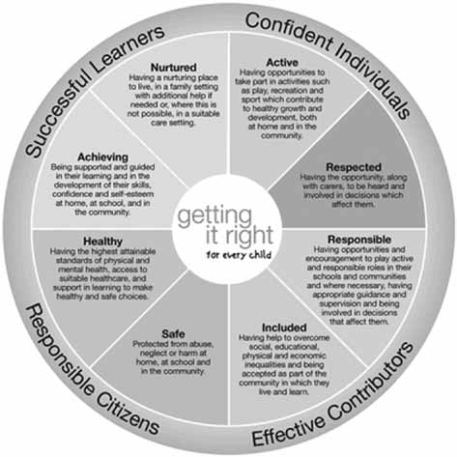
The strong links that exist between health and wellbeing, on the one hand, and achievements in learning on the other, are widely recognised in King’s Park Secondary School. Effective learning supports positive health and wellbeing, and good levels of health and wellbeing support effective learning. The impact of this inter-dependency on long-term health and social outcomes is most acutely played out in the crucial developmental period from early childhood through to the teenage years. That is when we can make the most positive impact and that is why we have such a core focus on children’s and young people’s health and wellbeing in key national policies such as Getting It Right for Every Child (GIRFEC) and Curriculum for Excellence.

CHILD PROTECTION AND SAFEGUARDING

At King’s Park Secondary School, we recognise that all staff have a crucial role in the support and protection of young people, as well as the development of their wellbeing. All staff know that they are expected to identify and consider the young person’s needs and share information and concerns with other agencies to improve outcomes for the young person. We strive to create and maintain a positive ethos and climate which actively promotes child welfare and a safe environment. Our Child Protection Coordinator is Mrs Preston (DHT Skye House), and should be contacted immediately if you have any concerns regarding Child Protection and Safeguarding.

At King’s Park Secondary School, it is the responsibility of every member of staff, partner and visitor to help ensure all our young people are safe.
This includes:
Protection from any form of abuse
Spotting signs of poor wellbeing and neglect

If you have any concerns please report them to Mrs Preston, our Child Protection Coordinator immediately. If Mrs Preston is not available please contact Mrs Ayed.

Mrs A Preston DHT  Child Protection Coordinator |  | Mrs K Ayed HT  Deputy CP Coordinator

PROMOTING POSITIVE BEHAVIOUR AND RELATIONSHIPS

Children’s Rights, as outlined in the UNCRC (United Nations Convention on the Rights of the Child) are fundamental to a good school ethos. Adults in King’s Park Secondary will work with young people to ensure that they are aware of their rights and fully respect the rights of others.

Our pupils and staff voted on the UNRC articles that most reflect our school community and those that we want to uphold in our daily interactions with each other. These are regularly promoted throughout the school year at whole school events and assemblies.

As a school community we embrace Restorative Approaches as a means of empowering teachers to be successful and effective practitioners within their classroom, raising standards and achievement across the school and developing aspirational, motivated and responsible pupils. All staff across the school are currently trained in the key principles of Restorative Approaches and we understand the importance of modelling positive language and behaviour and we take time to develop positive and meaningful relationships with colleagues and pupils. When positive relationships are developed and deep connections are made, individuals are less likely to cause harm to others or choose to damage relationships.

For occasions when unwanted behaviours arise, we use restorative approaches to help pupils understand the impact of their actions and behaviour. This method provides the opportunity for pupils and staff members to openly and respectfully discuss their perspectives around the concern, before coming to a resolution and a plan for moving forward. We believe that by using this restorative approach we are giving pupils the skills to independently make better, more responsible and more informed choices in the future.

It may be that a Pupil Support Teacher is present for the discussions as a facilitator and to ensure both individuals are equally heard and a fair resolution has been found. This has proved to be a most productive and constructive method for resolving matters and in some instances diffuses them at the outset.

Where a pupil regularly presents challenging behaviour, interventions will be put in place including;

- Support from Pupil Support Teacher
- Parent/carer being informed
- Parent/carer being invited to school for a meeting with Pupil Support and/or DHT
- The opportunity to reflect and identify more positive approaches to learning

If the interventions of support are not adequate to bring about a positive change in pupils behaviour, a pupil might be placed into NEST (New Expectations, Setting Targets). This allows for some further reflection and time out of classes to continue with their class work, supervised in our NEST room.

An adult presence is provided in the playground and pupil social areas at break times to promote positive behavior.

APPLYING THE NURTUREING PRINCIPLES ACROSS THE WHOLE SCHOOL

At King’s Park Secondary School, we have a Nurture space, to help some of our pupils settle more easily into the school day. Pupils attend the base every morning, period one, a Friday period six and two other times throughout the week. They work with our Principal Teacher of Pupil Support, our designated Nurture Teacher, and our Support for Learning Assistants. Pupils who would benefit from this are identified by House Depute Head Teachers and Principal Teachers of Pupil Support.

We are a Nurturing School – which means that we apply the six Nurture Principles to everything that we do.

The six principles are:

1. Children's learning is understood developmentally
2. The classroom offers a safe base
3. The importance of nurture for the development of wellbeing
4. Language is a vital means of communication
5. All behaviour is communication
6. The importance of transition in children's lives

Ref: Lucas,S., Insley,K. and Buckland,G. (2006) Nurture Group Principles and Curriculum Guidelines Helping Children to Achieve, The Nurture Group Network.

If you want to know more about how we do this, please do not hesitate to contact the DHT for Pupil Support at the school.

RIGHTS RESPECTING SCHOOLS AWARD

In 2023, we achieved Rights Respecting Schools Silver Award which is testament to the ongoing work between staff and pupils. This Award recognises achievements in putting the UNCRC into practice in our school to improve well-being and help all children and young people realise their potential. We are currently working towards our Gold Award while ensuring the UNCRC is embodied in everything we do.

There are four key areas of impact for children at a Rights Respecting school; wellbeing, participation, relationships and self-esteem. The articles in the UNCRC are used at all our assemblies and are within our School Charter.

The difference that a Rights Respecting school makes goes beyond the school gates, making a positive impact on the whole community. In King’s Park Secondary, we believe that every person in our school community is important. Working towards the Rights Respecting School Award helps us to celebrate and promote diversity and inclusion. We have included key dates and events in our school calendar to help us recognise and learn more about different groups of people:

Month | Event
October | Black History Month  Coming out Day  World Mental Health Day
November | National Anti-Bullying Week
December | World Aids Day  Int. Human Rights Day  Equality and Diversity Day
January | Holocaust Memorial Day
February | LBGT History Month
April | World Autism Day
May | Int. day against Homo/Bi/Trans phobia
June | Gypsy, Roma and Traveler History Months  World Refugee Day

If you want to know more about this Award, please do not hesitate to contact the school.

WHAT WE EXPECT OF ALL OUR PUPILS

Achieve your full potential in your school work

- By working hard and behaving well in all your classes.
- By taking a pride in the presentation and accuracy of all your written work.
- By listening carefully and taking part in class discussion.
- By doing all your homework.

Take an increasing responsibility for your own work

- By coming to lessons with the appropriate equipment, books and charged iPad.
- By aiming for full attendance at school.
- By being punctual to school and class.
- By setting yourself targets to achieve and monitoring your own progress.
- By developing good study habits and study skills.

Consider the needs of others

- By treating people as you would like to be treated.
- By making sure you do not disrupt the education of others.
- By moving around the school in a sensible way.

Be good ambassadors of the school both in school and out of school activities

- By dressing in school uniform.
- By being polite and considerate to all members of the school community and to
- visitors.
- By taking a pride in the school environment.
- By looking after your own property and respecting the property of others.

COMMUNICATION WITH PARENTS/CARERS

At King’s Park Secondary School, we strongly encourage all parents to become involved in the education of their children. We are always ready to listen to suggestions for new ways of stimulating parental interest. We contact and involve parents in many ways. For example:

Letters – Further information which requires a response may be sent out in letter form. These will also be sent out via groupcall

Text messaging/Email – You may also receive text/e-mail reminders about events/school closures/ letters issued, etc.

X (Twitter) – We update our X (formerly Twitter) account regularly with information about what’s happening in our school.

Meetings - Parents are carers are welcome to contact the school to make arrangements to discuss any aspect of their child's progress, usually through their child's Pupil Support Teacher. Details and arrangements of parent/carer meetings to discuss subject specific progress will be shared through the parental school calendar and parents and carers are encouraged to attend these where possible. We offer two parent/carer meetings for each year group – one face-to-face in school and one virtual meeting using your child’s Microsoft Teams account on their iPad.
School website – Will contain a great deal of information about the school. It is a good idea to check this regularly.

Family Engagement - We have 2 FARE workers called Nick and Carly who have a specific remit of engaging with families within our community and linking in with external agencies and organisations for support. They work closely with young people and their families helping to develop stronger relationships with the school and enabling them to fully access their Education. FARE provide youth work, group work, community outreach, our breakfast club and successful Holiday Programmes as well as much more. Further details of group work and after school events will be shared with young people and parents/carers.

Parents and carers are welcome at other events throughout the school year e.g. workshops, information evenings, focus groups, award ceremonies. The school will keep you informed.

Strong communication links between home and school ensure parents and carers are confident to address any concerns they may have about their child’s education with Pupil Support Staff and the Senior Leadership Team.

TRANSPORT

All children and young people aged 5 – 21 year of age can now travel by bus free by applying for a National Entitlement Card (NEC Card). You can apply online at getyournec.scot or if you don’t have all the proofs required, you can collected an application form from our School Office. Please speak with your child’s Pupil Support teacher for more information.

PARENT FORUM AND PARENT PARTNERSHIP

The Scottish Schools (Parental Involvement) Act 2006 has changed the arrangements for parental representation in all schools. Since August 2007, all parents/carers are automatically members of the Parent Forum for their school and they have a right to establish a Parent Council to represent them.

PARENT FORUM

The membership of the Parent Forum is made up of all parents/carers who have a child at an education authority school. Membership of the Parent Forum allows parents/carers to have a say in the local arrangements to enable their collective view to be represented on matters such as the quality and standards of education at the school and other matters of interest to parents. One of the ways parents/carers in the Parent Forum will be able to express their views will be through the Parent Partnership.

PARENT PARTNERSHIP

The Parent Partnership is a group of parents selected by members of the Parent Forum to represent all the parents/carers of children at the school. Parent Councils are very flexible groups and the Parent Forum can decide on the type of group it wants to represent their views. The type of things a Parent Council could get involved in includes:

- Supporting the work of the school;
- Gathering and representing parents’/carers’ views to the Head Teacher, education authority and Education Scotland;
- Promoting contact between the school, parents/carers, pupils and the local community;
- Involvement in the appointment of senior school staff.
- Fundraising.

Minutes of the Parent Partnership are available on the school website.

Parents who would like to join the group would be made most welcome. Please contact the school or e-mail us directly: kpssparentpartnership@gmail.com

YOUTH PARLIAMENT

Our Youth Parliament is made up of 2 representatives from each year group. We hold yearly elections in which the pupils choose who they want to represent them for each year group. Pupils serve two years when they are elected. This is an important group which ensures that the views of pupils are heard.

RELIGIOUS OBSERVANCE

Our school is fortunate to have a close link with our local churches including Croftfoot, Cathcart Old Parish and Clincarthill Parish Church. The ministers assist with the Christianity element of Religious and Moral Education and provides opportunities for religious observance. Parents have the right to withdraw their child from religious observance and should inform the school in writing.

In addition, parents and carers from religions other than Christianity may request that their children may be permitted to be absent from school in order to celebrate recognised religious events. Only written requests detailing the proposed arrangements will be considered. Appropriate requests will be granted on up to 3 occasions in any one school session.

ASSESSMENT & REPORTING

All young people are assessed both formally and informally throughout the school year. This allows young people and their teachers to identify their strengths and areas for improvement. A variety of assessment methods are used to enable staff to pass on information to parents and carers about the progress of their child. Assessment records are kept by teachers and form the basis of discussion at parents’ meetings throughout the year.

Dates of all parents’ meetings and the schedule for issuing tracking reports are included in the school calendar, which is issued at the start of term and is available on the website.

If you have any concerns about your child’s progress do not hesitate to contact their Pupil Support teacher at any time.

S3 PUPIL PROFILES

All S3 learners have a profile which reflects their progress in learning and achievement and emphasis’s their strengths. The profile documents their key achievements in school, at home and in the community and the content is decided by the young person. The profile provides a valuable way for learners to share information about their achievements with their parents, teachers and in the future, staff in colleges, universities and employers. The profile also supports the move from S3 into the senior phase of secondary school and is the basis for a general, skills-based interview with our Careers Advisors.

HOMEWORK

Regular, effective homework is an important part of the school day. We use ‘Satchel: One’, which is an online homework facility where teachers issue homework while pupils and parents can access the details through a PC or suitable device. Parents are asked to check this on a regular basis. Homework has many advantages:

- It reinforces work done in class.
- It develops good study habits and a sense of personal discipline.
- It develops areas of interest that can be followed up later in life and become a leisure pursuit.
- It allows parents to see, help and become involved in their child’s work.

The amount of homework varies in length, nature and frequency depending on the subject. The amount of homework will increase as your child progresses through the school. Pupils should access their tasks through the appropriate platforms including ‘Microsoft Teams’ and ‘Showbie’ as directed by their class teacher.

SUPPORTED STUDY

This is an important initiative which allows pupils to attend additional classes during lunchtimes, after school and during holiday periods. Large numbers of our staff give generously of their time in this area. Subjects on offer will depend on the staff available to deliver. Pupils will be kept informed of the arrangements.

CURRICULUM DESIGN AND PLAN

Our curriculum includes a three-year Broad General Education (S1-S3) and a three-year Senior Phase (S4-S6). Throughout the Broad General Education (BGE) all pupils study all 8 curricular areas as outlined by the Scottish Curriculum for Excellence: Expressive arts, Health and wellbeing, Languages, Mathematics, Religious and moral education, Sciences, Social studies and Technologies. At the end of S2, pupils are able to personalise their curriculum by choosing specific subjects within each of these 8 curricular areas. Throughout the BGE, pupils engage in Interdisciplinary learning by choosing to specialize in outdoor learning, learning for sustainability, STEM or digital learning.

In the Senior Phase, pupils can choose to study a range of National Qualifications including National 4/5 courses, National Progression Awards and Skills for Work courses.

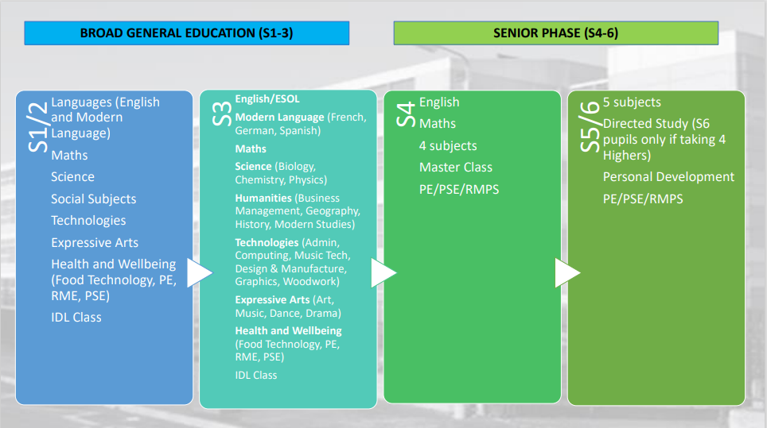

SESSION 2023-24 HOLIDAYS

August
- Monday, 14 August 2023 (Return date for Teachers & In-Service Day)
- Tuesday, 15 August 2023 (In-Service Day)
- Wednesday, 16 August 2023 (Return date for Pupils)

September
- Friday, 22 September and Monday, 25 September 2023 (September weekend holiday)

October
- Friday, 13 October 2023 (In-Service Day)
- Monday, 16 to Friday, 20 October 2023 (October Week)

December - Christmas and New Year
- Schools close at 2.30 pm on Friday, 22 December 2023
- Monday, 25 December 2023 – Friday 5 January 2024 (Christmas holidays)

January
- Schools return on Monday 8 January 2024

February mid-term break
- Monday, 12 February 2024
- Tuesday, 13 February 2024
- Wednesday, 14 February 2024 (In-service day)

April - Spring Holiday (Easter)
- Schools close at 2.30 pm on Thursday, 28 March 2024
- Good Friday 29 March 2024
- Easter Monday 1 April 2024
- Monday, 1 April - Friday, 13 April 2024 (Spring Break)
- Schools return on Monday, 15 April 2024

May
- Thursday, 1 May 2024 (In-service day to coincide with UK Parliamentary elections, subject to change)
- Monday, 6 May 2024 (May Holiday)
- Friday, 24 May 2024 and Monday, 27 May 2024 (May Weekend)

June
- Schools Close at 1.00 pm on Friday 26 June 2024

SCHOOL IMPROVEMENT

On an annual basis, you will receive a copy of our Standards and Quality report. The report will be used to share the overall exam performance of the school and highlights progress in key curricular areas.

Our priorities for improvement are detailed in our School Improvement Plan which is discussed with our Parent Partnership. Any parent or carer seeking a copy of the plan should contact the school office or access it via the school website.

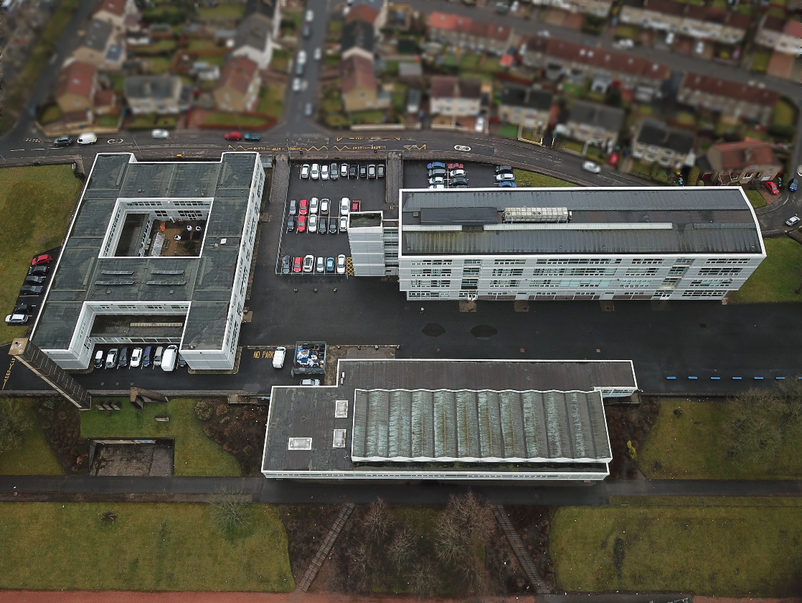

COMMENTS AND COMPLAINTS

In Glasgow Secondary School we aim to have positive relationships across our school community. However, if you have a comment or complaint about any aspect of school life, please contact the Headteacher in the first instance.

Glasgow City Council complaints procedures are available:
https://www.glasgow.gov.uk/index.aspx?articleid=16133

Customer Care Team
Customer & Business Services
Glasgow City Council
City Chambers
Glasgow G2 1DU

Tel: 0141 287 0900
e-mail: customercare@glasgow.gov.uk or education.customerservices@glasgow.gov.uk

USEFUL CONTACTS

Parentzone Scotland is a unique website for parents and carers in Scotland, from early years to beyond school. The website provides up-to-date information about learning in Scotland, and practical advice and ideas to support children’s learning at home in literacy, numeracy, health and wellbeing and science. Information is also available on Parentzone Scotland regarding additional support needs, how parents can get involved in their child’s school and education. Furthermore, the website has details about schools including performance data for school leavers from S4-S6; and links to the national, and local authority and school level data on the achievement of Curriculum for Excellence levels.

Useful websites and contacts:

Education Scotland www.education.gov.scot
National Parent Forum of Scotland www.npfs.org.uk

Connect
Connect is a national organisation that provides advice and resources for parents and carers. www.connect.scot

Enquire Scotland
Enquire is a national advice service for families with additional support needs. www.enquire.org.uk

Education Services
City Chambers East
40 John Street
Glasgow G1 1JL
Tel: 0141 287 2000

www.glasgow.gov.uk

