Fasting in Ramadan

Guidance for schools

when meeting the needs

of Muslim young people and staff.

Education Services Glasgow City Council

(2022)

Introduction

This guidance has been prepared to support schools better meet the needs of Muslim young people during Ramadan, particularly when Ramadan takes place during the SQA exam diet. It also provides advice for staff too.

Education Services very grateful to the advice provided by the Al Meezan Islamic Women’s Centre, to Lewisham Council their comprehensive document on which this guidance is based and that advice provided by Muslim colleagues who work for Glasgow City Council.

"Oh, you who believe! Fasting was prescribed for you as it was prescribed for those before you, that you may become righteous."

Surah Al-Baqarah (The Cow) – Holy Qur'an 2:183

Fasting in the month of Ramadan, the month of revelation of the Holy Qur'an, is an obligation for all Muslims past the age of puberty. There are exemptions from these requirements for some people, such as the sick, those engaging in a long journey, menstruating women, or those who are frail in old age. Exemptions can be made up later or compensated for, e.g. by fasting on another day or by feeding the poor. Fasting at other times is also encouraged but is non-obligatory.

Fasting is undertaken by Muslims for the sake of Allah, the Creator, the Merciful, the Loving (to mention just three of His names or attributes) and is regarded as an atonement of human failings. It cultivates virtues such as piety, love of God, brotherhood, vigilance, devotion, patience, unselfishness, moderation, thriftiness and satisfaction with what one has, discipline, social belonging, self- control, and compassion for fellow human beings who might suffer hunger and deprivation unwillingly.

HEALTH BENEFITS OF FASTING:
- It gives the digestive system a rest
- Can help you beat addictions
- It is a great way to start a healthy diet
- Normalizes insulin sensitivity
- Reduces your hunger levels
- Promotes the detoxification process
- It helps whiten the eyes and clears the complexion
- Can reduce high blood pressure
- It can boost the immune system

(www.healthdigest.com)

Fasting in Islam is not merely denial of food and drink alone. Muslims believe they should also try to restrain their other senses, such as the eye, ears, and particularly the tongue, avoiding backbiting, scandal- mongering, obscenity, confrontation and such matters.

To fast during Ramadan is one of the main requirements of the Islamic faith. Muslims are required to abstain from all food, drink (and sexual activity, where appropriate), from dawn to nightfall through the 30 or 29 days between one new moon and the next. The daily fast begins before the time of the Fajr (dawn) prayer and finishes at the time of Maghrib (sunset) prayer.

Schools need to be aware of the added challenge of fasting in Scotland when the long daylight hours between dawn and sunset during the summer months.

It is very important for many Muslim families that their children should begin participating in the practice of fasting at an early age. Secondary young people will be expected to fast.
Many primary school children will be fasting as well with younger pupils fasting possibly for part of Ramadan, or only on certain days of each week. It is likely that the whole family will be observing fasting which will mean the whole household will be awake earlier in the morning and will stay up later at night. Young children may well become more tired or excitable in school during this time even if they are not fasting themselves.

Points to consider

Schools should consider the following points in determining their approach to the needs of the Muslim young people and staff in their care during Ramadan.

Schools should:

- inform and reassure parents /carers in advance how they will support pupils who are fasting, including any special provisions that will be made for pupils who are fasting during Ramadan.

- in primary schools, in partnership with parents, establish a register of those pupils who will be fasting, what their fast will involve (e.g. are they abstaining from drink as well as food) and on which days, based on parental permission, given either verbally or in writing.

- make special provision at lunchtimes for pupils who are fasting but cannot go home. They may want to rest and be quiet or they may enjoy taking part in special activities that can be arranged for them while other pupils are having their lunch. The alternative place should not be near the dining facilities in the school. They may also wish to perform prayers at this time, or to share reading the Qur'an with other Muslim pupils or staff.

- ensure that no pupil who is fasting is required to do anything that would make her/him break the fast or become dehydrated or weak. This could include swimming, cross- country running or weight-training.

- anticipate that fasting may make some pupils weak or tired, and adapt the curriculum as appropriate. This could mean, for example, planning less energetic activities in P.E particularly if Ramadan falls during the longest days.

- where possible, use the fact that pupils are fasting to inform and enrich the curriculum experience both for themselves and others. It could provide a starting point for discussions in a number of subjects, such as religious education, history, P.E., health education, performing arts, geography, science and in collective worship.

- be careful with the timing of evening events such as parents’ evenings or prize -giving’s etc. so that staff and pupils have time to return home to break their fast. If Ramadan falls in the summer months then these events should be avoided, where possible.

Prayer facilities:

Many Muslim staff and older Muslim pupils who are fasting may like to have the opportunity to pray at lunchtime.

Schools should:

- provide appropriate rooms that are sensitive to the needs of the participants, where possible one for girls and one for boys if these are not already made available for this purpose throughout the year;

- make available washing facilities and a vessel for washing. Those praying will need to wash their arms and feet which, because facilities are not built for this purpose, may mean some spillage which will need to be prepared for;

- allow those wishing to pray to bring prayer mats, and if they wish to, slippers to wear after ablution. Sensitive storage for these items needs to be agreed with those concerned.

SQA Examinations

Secondary pupils observing the fast will have consumed their last food and drink before dawn. Given the importance of hydration for maintaining concentration, it would not be surprising if exam performance was to suffer.

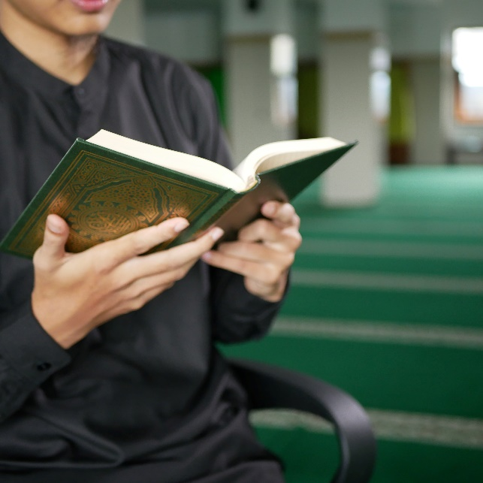
Schools need to ensure that invigilators are given this guidance to allow them to fully understand the needs of Muslim candidates who are fasting.

Schools should seek to reduce any disadvantage by considering how best to support staff and pupils during periods of fasting that clash with the exam period. If schools have concerns about the wellbeing of any pupil then they should discuss those concerns with parents/carers and the young person themselves while respecting their faith.

Assessments

For other year groups, during Ramadan the timing of assessments should be reviewed to ensure that pupils do not have too many assessments on the same day, or that special arrangements are made to allow some pupils to be assessed at different times. School plans for other arrangements, such as supported study and the location of rooms could be reviewed to minimise the impact on those who are fasting.

Assemblies

It is good practice to use assemblies to acknowledge and explain about Ramadan. It is also helpful to check that the content of all assemblies during this time is planned sensitively towards pupils who may be feeling weak or hungry.

After school and out of school activities:

Schools may wish to consider adapting some extra-curricular activities during Ramadan for practical reasons. This should be considered no matter how many Muslim young people are in the school.

If the normal programme of activities is to be maintained, it is very important to ensure that pupils do not suffer in any way through not being able to participate. An example of this would be where 100% attendance at lunchtime practices is required by members of sporting teams.

When planning an annual calendar of out of school visits, schools should take into consideration the timing of the Ramadan so that one-off special opportunities are not denied to Muslim pupils.

With younger pupils who are not fasting every day it is usually possible to arrange with their families that they do not fast on a particular day so to participate comfortably in an outing.

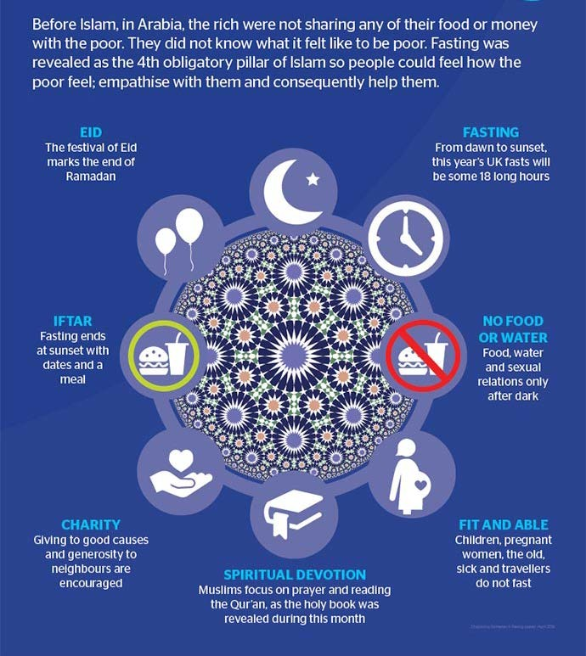
Anglia Ruskin University/ Student Service / Chaplaincy.

Celebrating Eid in school:

Eid-ul-Fitr at the end of Ramadan is a great day of celebration for Muslim families. Schools across the city use a range of ways to celebrate, for example, through special assemblies or:

(huffingtonpost.ca)
- Holding an Eid party at lunch time offering selective dishes such as samosa, rice, kebabs
- Children, from all communities, joining in and fasting during the school day to raise money for charities. Ramadan is often referred to as the month of charity as giving to those less fortunate is a requirement during this important period.
- Henna parties
- Visits to local mosques

Cultural lunches after Ramadan: Schools could highlight how Muslims share or donate food at the end of Ramadan to those who cannot afford to celebrate Eid, and link this to how as a society we are supporting our fellow citizens often in their basic needs and rights through food banks.

Eid-ul-Fitr is also a time to celebrate an achievement, for example, fasting for a whole month, and this could be linked to the different ways in which we celebrate our collective achievements as a society (as faith groups or otherwise.

These are but a few ideas, the main point is for everyone to join in and enjoy the festivity, whilst learning a little more about each other’s culture and beliefs

Absence for Religious Observance Pupils
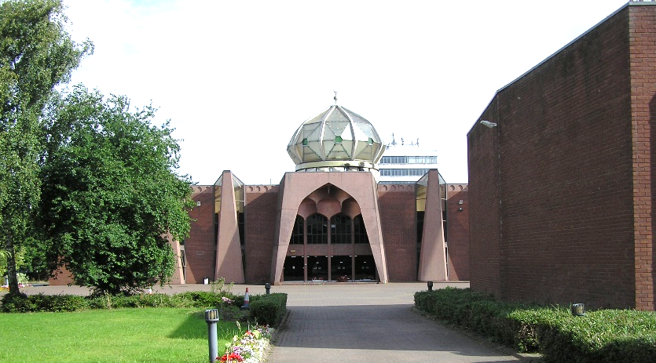
A one day authorised absence for religious observance at Eid-ul-Fitr (a 10 day holiday in some Muslim countries) and another at Eid-ul-Adha (the festival at the time of the annual Hajj Pilgrimage). If parents/carers request further days, then consideration should be given to this. Each case should be considered on an individual basis, looking at patterns of absence and the impact on the overall attendance level.

Please note that the Islamic calendar is subject to the sighting of the new moon, or the news of this from recognised Islamic authorities. Therefore, there is some uncertainty in establishing the date until the last moment. It should also be understood that different Muslims in Britain might follow different days depending on their country of origin or the school of thought they follow.

Staff

Management Circular 68 provides advice on leave of absence for teachers. Up to three days paid leave per school session may be granted in circumstances where religious observance is required outwith current leave and school closure days.

This link provides guidance on Ramadan for other Council employees. http://connect.glasgow.gov.uk/CHttpHandler.ashx?id=25290&p=0 . Staff should discuss any requirements they may have during Ramadan with their manager.

Where staff are not working term-time then they should consider their use of leave and flexible working arrangements. Term-time staff should discuss their requirements with their manager. Managers are asked to try to accommodate requests for leave and flexible working arrangements, while taking into consideration service delivery requirements.

Staff are encouraged to tell their colleagues that they are fasting so that colleagues can be considerate.

Parents

The school's policy regarding holidays for religious observance should be shared with parents/carers and included in the school handbook.

In advance of Ramadan, all parents/carers of Muslim pupils should receive information about the school's arrangements; either through a letter in English or translation. It might also be helpful to hold a meeting in school. Education Services promotes strong partnership with parents and carers. Sharing this information will help the school to:

  - acknowledge the importance of Ramadan and Eid-ul-Fitr in Islam and show parents that we are concerned and supportive of their child and the family’s faith;

  - be clear on the position of authorised absence for religious observance and stress the need for parents/carers to ensure that their children are not absent for more days than are authorised;
  - outline the special provisions that will be made for pupils who are fasting during Ramadan;

  - request confirmation from parents/carers of primary age pupils about whether their child will be fasting during Ramadan, and if so, on which days. Or give parents/carers an opportunity to come into school to discuss how best to decide on which days to allocate fasting and which to avoid;

  - give details of any plans for the celebration / marking of Eid in schools;

Other resources:

Central mosque and local places of worship are open to school visits throughout Ramadan. School parties are always welcome. The main mosque in Glasgow the Central Mosque and their contact details are:

There are lots of videos available, for children and by children on Ramadan, again this maybe a resource to share with a class for a discussion.

You tube videos for children: https://www.youtube.com/watch?v=s-zZvH_mXTw Five minute video for children: https://www.youtube.com/watch?v=YUJYEGAt4cQ CBB ‘What is Ramadan’: https://www.bbc.co.uk/newsround/23286976

Appendix

Examples of good practice

Shawlands Academy provides prayer rooms separated for boys and girls throughout the year.

Ramadan is discussed at all year group assemblies to ensure that all young people know what is involved and why their classmates are fasting. The school engages in a range of additional activities. For example, there is a tradition of a ‘cultural lunch’ where S6 celebrate their diverse cultures – this happens outwith Ramadan.

During the year, social dancing can be an issue which is resolved by taking a flexible approach, for example, having pupils dance with a friend regardless of gender or walking rather than dancing. However, during Ramadan, the school would ensure that these activities were minimised respecting the importance of Ramadan.

The school recognises that it requires all staff being sensitive to the needs and views of others.

When Ramadan is ending, if the timing is appropriate, the school holds an Iftar event at sunset.

Ramadan and Eid are clearly marked and included in the school calendar. The school ensures that any major events such as the Leavers’ prom are not included during Ramadan.

Where any issues arise, advice and guidance is sought from the Central Mosque.

At Bellahouston Academy, a member of staff offers the opportunity for daily prayers every morning before school starts.

The school has made arrangements for a quiet space for pupils who want to avoid the dinner hall at lunch time.
S5/6 pupils are usually welcome to make tea/coffee - staff encourage pupils to think about people who are fasting and if it will distract them - as a result pupils who are not fasting are quietly aware of those pupils who are fasting and if they are struggling or not and act accordingly.
Some staff take into consideration the homework levels for S5/S6 during Ramadan and give less extensive homework activities.

