

King’s Park Secondary School

P7 Transition Programme

May 2020

**P7**

**FRANÇAIS**

**FRENCH**



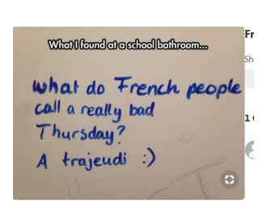

***Can you explain the joke?***



What can you expect from this French lesson?



* **Use clues to understand** unknown vocabulary
* Answering questions based on **previous knowledge**
* **Working out** possible meaning of new words
* **Be active** and revise numbers!



***Activity 1: In Mr Pegard’s video clip you see the following comments about his hair in French and Spanish. What do you think they might mean?***

|  |  |  |
| --- | --- | --- |
| [https://r1.res.office365.com/owa/prem/images/dc-mpg_20.png](https://glowscotland-my.sharepoint.com/personal/gw09pegardmathieu_glow_sch_uk/Documents/Attachments/Transition%20presentation_director%27s%20cut.mp4) | [Transition presentation_director's cut.mp4](https://glowscotland-my.sharepoint.com/personal/gw09pegardmathieu_glow_sch_uk/Documents/Attachments/Transition%20presentation_director%27s%20cut.mp4) |  |

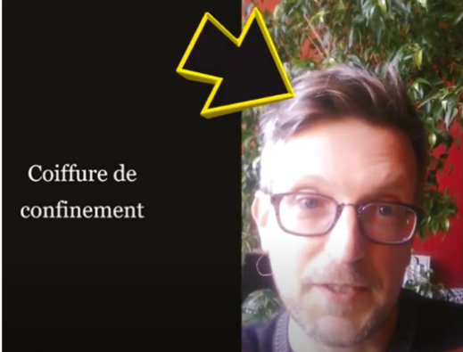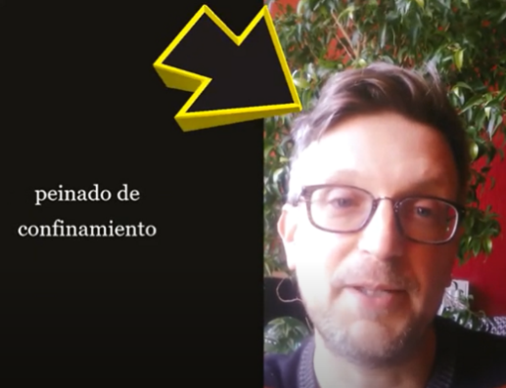

**French counting challenge!**

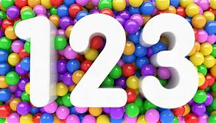

• On the next page you’ll find a mixture of active and counting challenges!

• Choose which ones you would like to try and count each one in French as you are doing it.

* **For practice beforehand and numbers help**, see below!

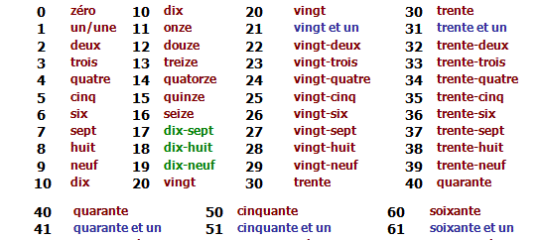

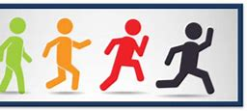

**Prêts? Allez-y!**

**Can you guess what these challenges are?**

|  |  |  |
| --- | --- | --- |
| Saute  à la  corde! | Compte les voitures dans la rue! | Compte des arbres! |
| Compte des oiseaux! | Fais rebondire une balle! | Fais la planche! |
| Joue à la marelle! | Jongle avec un ballon de foot! | Fais des sauts en étoile! |
| Pose comme un arbre! | Danse le floss! | Compte des insectes! |

**Help for these challenges on the next page**

|  |  |  |
| --- | --- | --- |
| **French** | **English** | **Notes** |
| Saute à la corde! | Skip with a skipping rope! | You can do this with a skipping rope or just skip |
| Compte les voitures dans la rue! | Count the cars on the street! | Count the cars you can see parked or which pass |
| Compte des arbres! | Count trees! | Count the trees you see on your walk, in your garden or near your house |
| Compte des oiseaux! | Count birds! | Pick a location and watch for a set time, how many can you see? |
| Fais rebondir une balle! | Bounce a ball! | Bounce it as many times as you can in a given time |
| Fais la planche! | Do a plank! | Hold it for as long as you can, see if somebody wants to compete! |
| Joue à la marelle! | Play hopscotch! | Say the numbers in French as you play |
| Jongle avec un ballon de foot! | Do some keepie uppies! | Do as many as you can and count in French |
| Fais des sauts en étoile! | Do star jumps! | Do as many as you can and count in French |
| Pose comme un arbre! | Do a yoga tree pose! | Hold it for as long as you can! |
| Danse le floss! | Dance the floss! | Do as many as you can and count in French |
| Compte des insectes! | Count insects! | See how many insects you can find outside, classify them. |

