**[](http://www.kingspark-sec.glasgow.sch.uk/)**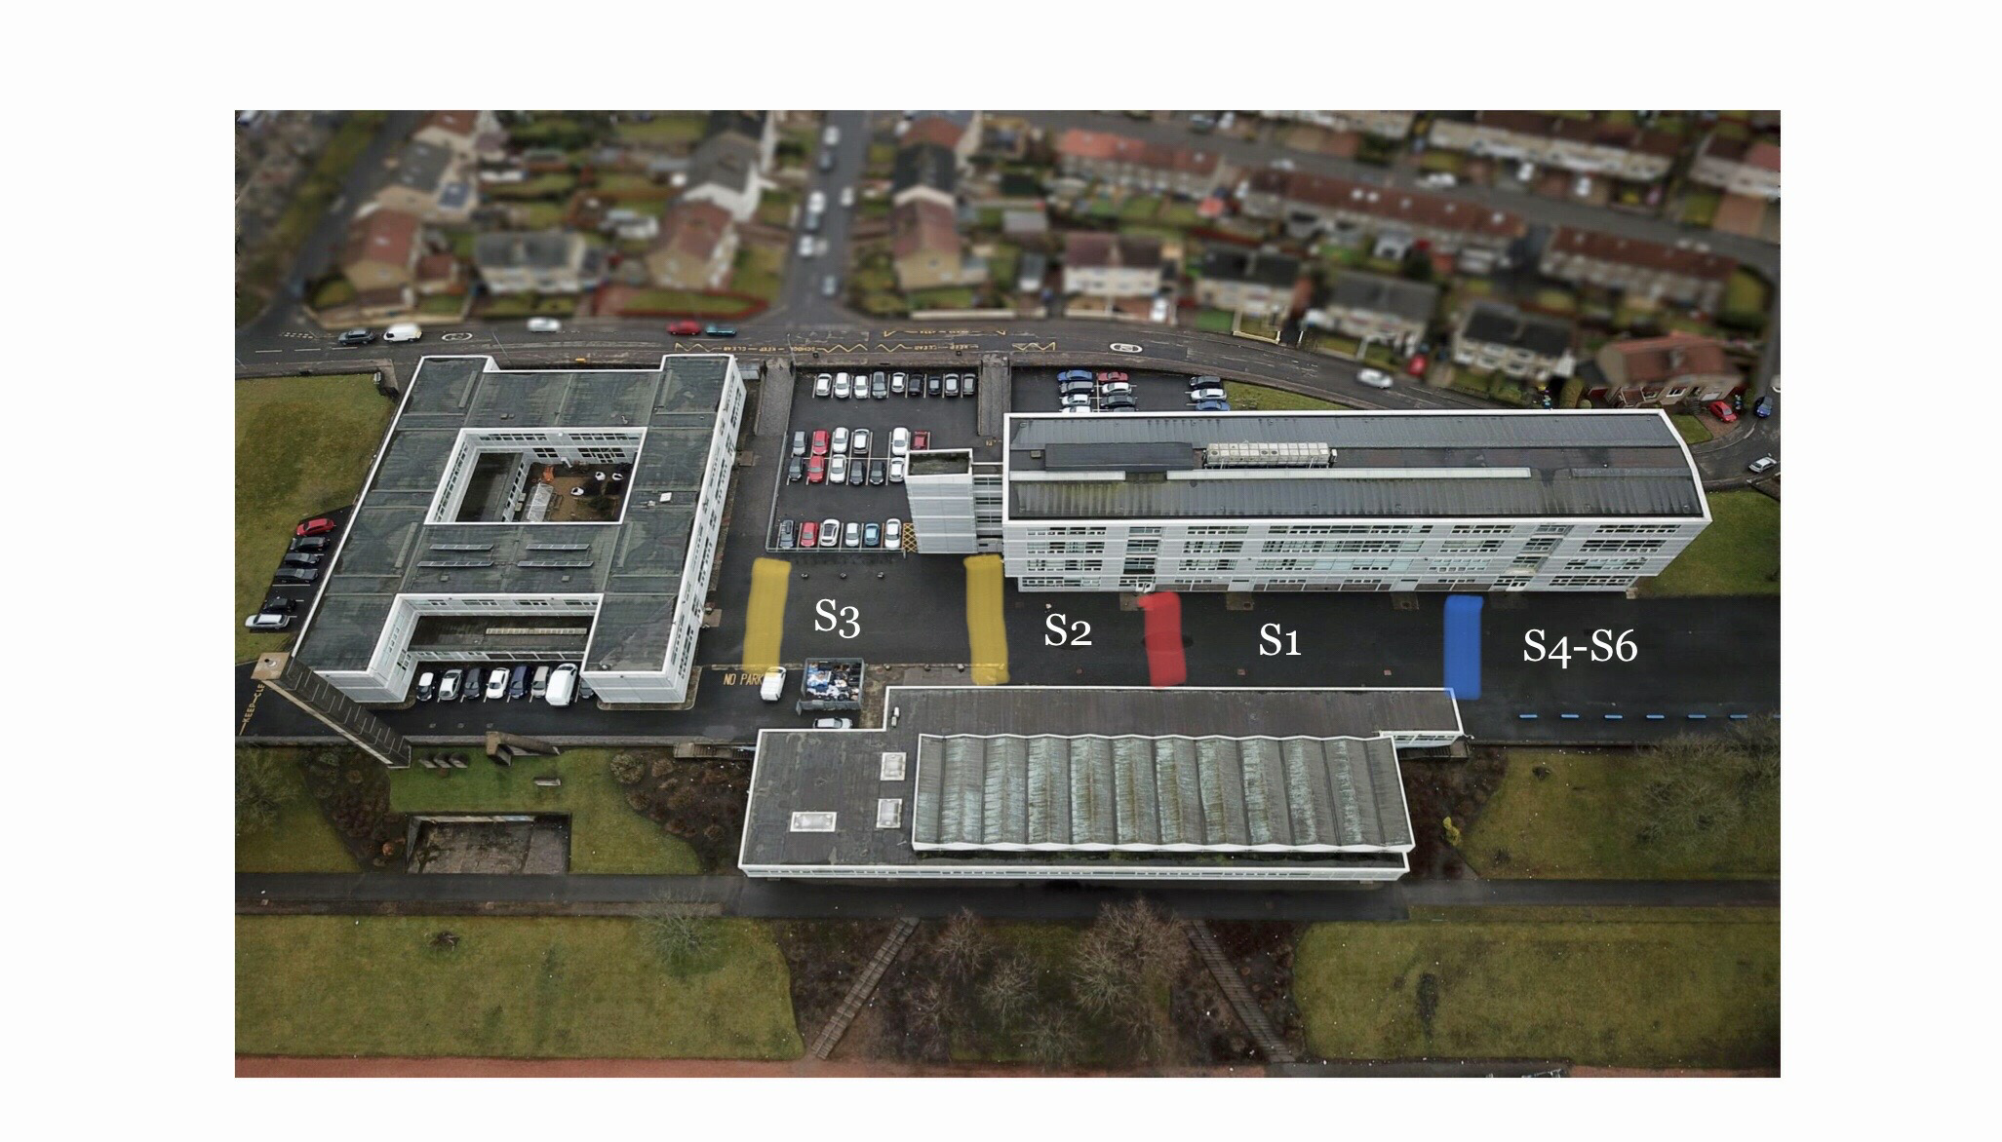

**King’s Park Secondary School**

**Year Group Outdoor Spaces**